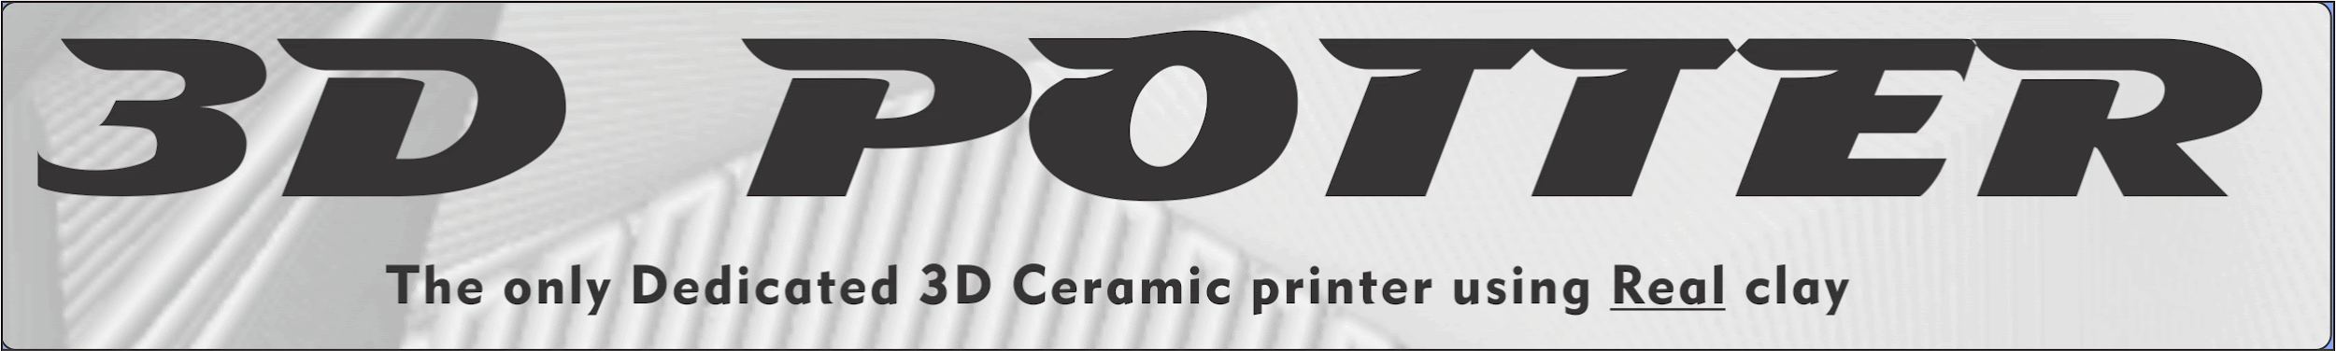

3D Potterbot 9 series: Full manual for version 9 and up

Please watch the videos: Youtube 3D Potter Tech Support

Box to Pot 2: Assembly Tutorial: https://www.youtube.com/watch?v=2DVUnrFeb7Y (18 min)

Connecting to your Printer: https://www.youtube.com/watch?v=5__oClYqolI (3 min)

The electronic version of this manual and all of its links can be found on our FAQ under the Getting started section: https://3dpotter.com/faq

Limit Switches
All 3D Potter, Inc. printers have 3 limit switches, one for each of our rails (X, Y, and Z). These switches are small, precise instruments that are fragile. For shipping, we cover them with masking tape to protect them from being caught on the packing foam or other parts of the printer. This tape must be removed before use. During assembly, they must be plugged in. If a limit switch is not plugged in or doesn’t have its protective tape removed, it will not function properly. The cars that travel on the rails will crash into the limit switch, potentially damaging it.

Omni wheels
Your 3D Potterbot has a unique mechanism of traveling X-axis utilizing Omni wheels. They are already calibrated to the correct height from the factory (1 to 2mm above the table). In order for them to work properly, the wheels should not actually make contact with the surface of the table when the X-axis is at rest (weight balanced on both sides of the rail). The printer has to be placed on a flat surface for both wheels to work correctly. If the wheels are constantly under pressure, this will put undue stress on the mechanism and can cause the printer to shift during prints. Keep the wheels clean from debris and clay as much as possible.

Acme screw
The Acme screw is greased from the factory. Keep it free from clay or debris and use lube regularly. We recommend: Oil-based Lithium Grease, White.
https://www.homedepot.com/p/Lucas-Oil-8-oz-Lithium-Grease-White-10533/202535870
The Acme screw and black square nut at the top of the Acme screw do not rotate and are not meant to rotate. The square anti rotator tube that is mounted to the top of the gearbox is meant to keep the ACME shaft from rotating. The internal nut inside the gearbox, which is not visible, is the only part that rotates.

Loading the tubes
Prepare clay to the consistency of soft throwing clay, it must be clean and consistent. Several ways of loading the tubes are described in the FAQ section of our web site.
Use all of the fasteners in the clay tube without eliminating any of them because of the high pressure. When using the smallest nozzles (1 or 2 mm) the clay consistency should be softer to reduce the pressure on the extruder and nozzles.

PRIME
When you initially load the tube with clay it will take some time for the prime program to pressurize the clay until it comes out of the nozzle. The Acme screw does not spin and moves downward very slowly. Use the prime file to pressurize the tube prior to printing. Once the clay starts coming out of the nozzle, you can stop the program and you are ready to print.

RETRACT
Unload the pressure of the clay in the extruder at the end of the day or for storage. You should run this program for about 10-20 seconds. When it is very hard to unscrew the fasteners during tube changing, stop immediately. It is a clear indication that the tube is under pressure and you could strip the fasteners and/or crack the tube.

Storing pre-loaded tubes
Properly prepared clay can last up to three months or more in the tube, only if the pressure is taken off after printing. Use the Retract file or better yet, include a small retraction script in your ending G-Code. If you leave the clay under pressure, the clay will slightly harden and the possibility of water migration and hardening is possible. If your clay is too hard for the extruder, this can cause damage and bending of the Acme screw which is not covered under warranty.

Changing the tubes
When changing the tubes, make sure the pressure of the clay is unloaded by using the RETRACT file as described above. Push the piston and nozzle assembly out of the tube by using a cardboard tube or PVC pipe that fits inside the tube (largest diameter you can easily fit in).

Setting the Z height of the extruder (after reloading)
With the extruder unmounted from the printer, run the Print Start Location Gcode file, let the Z-axis descend all the way. Next, place a small shim approximately 2-3 mm thick on the bat. Place the extruder nozzle on the shim and lock the clamp for the extruder.
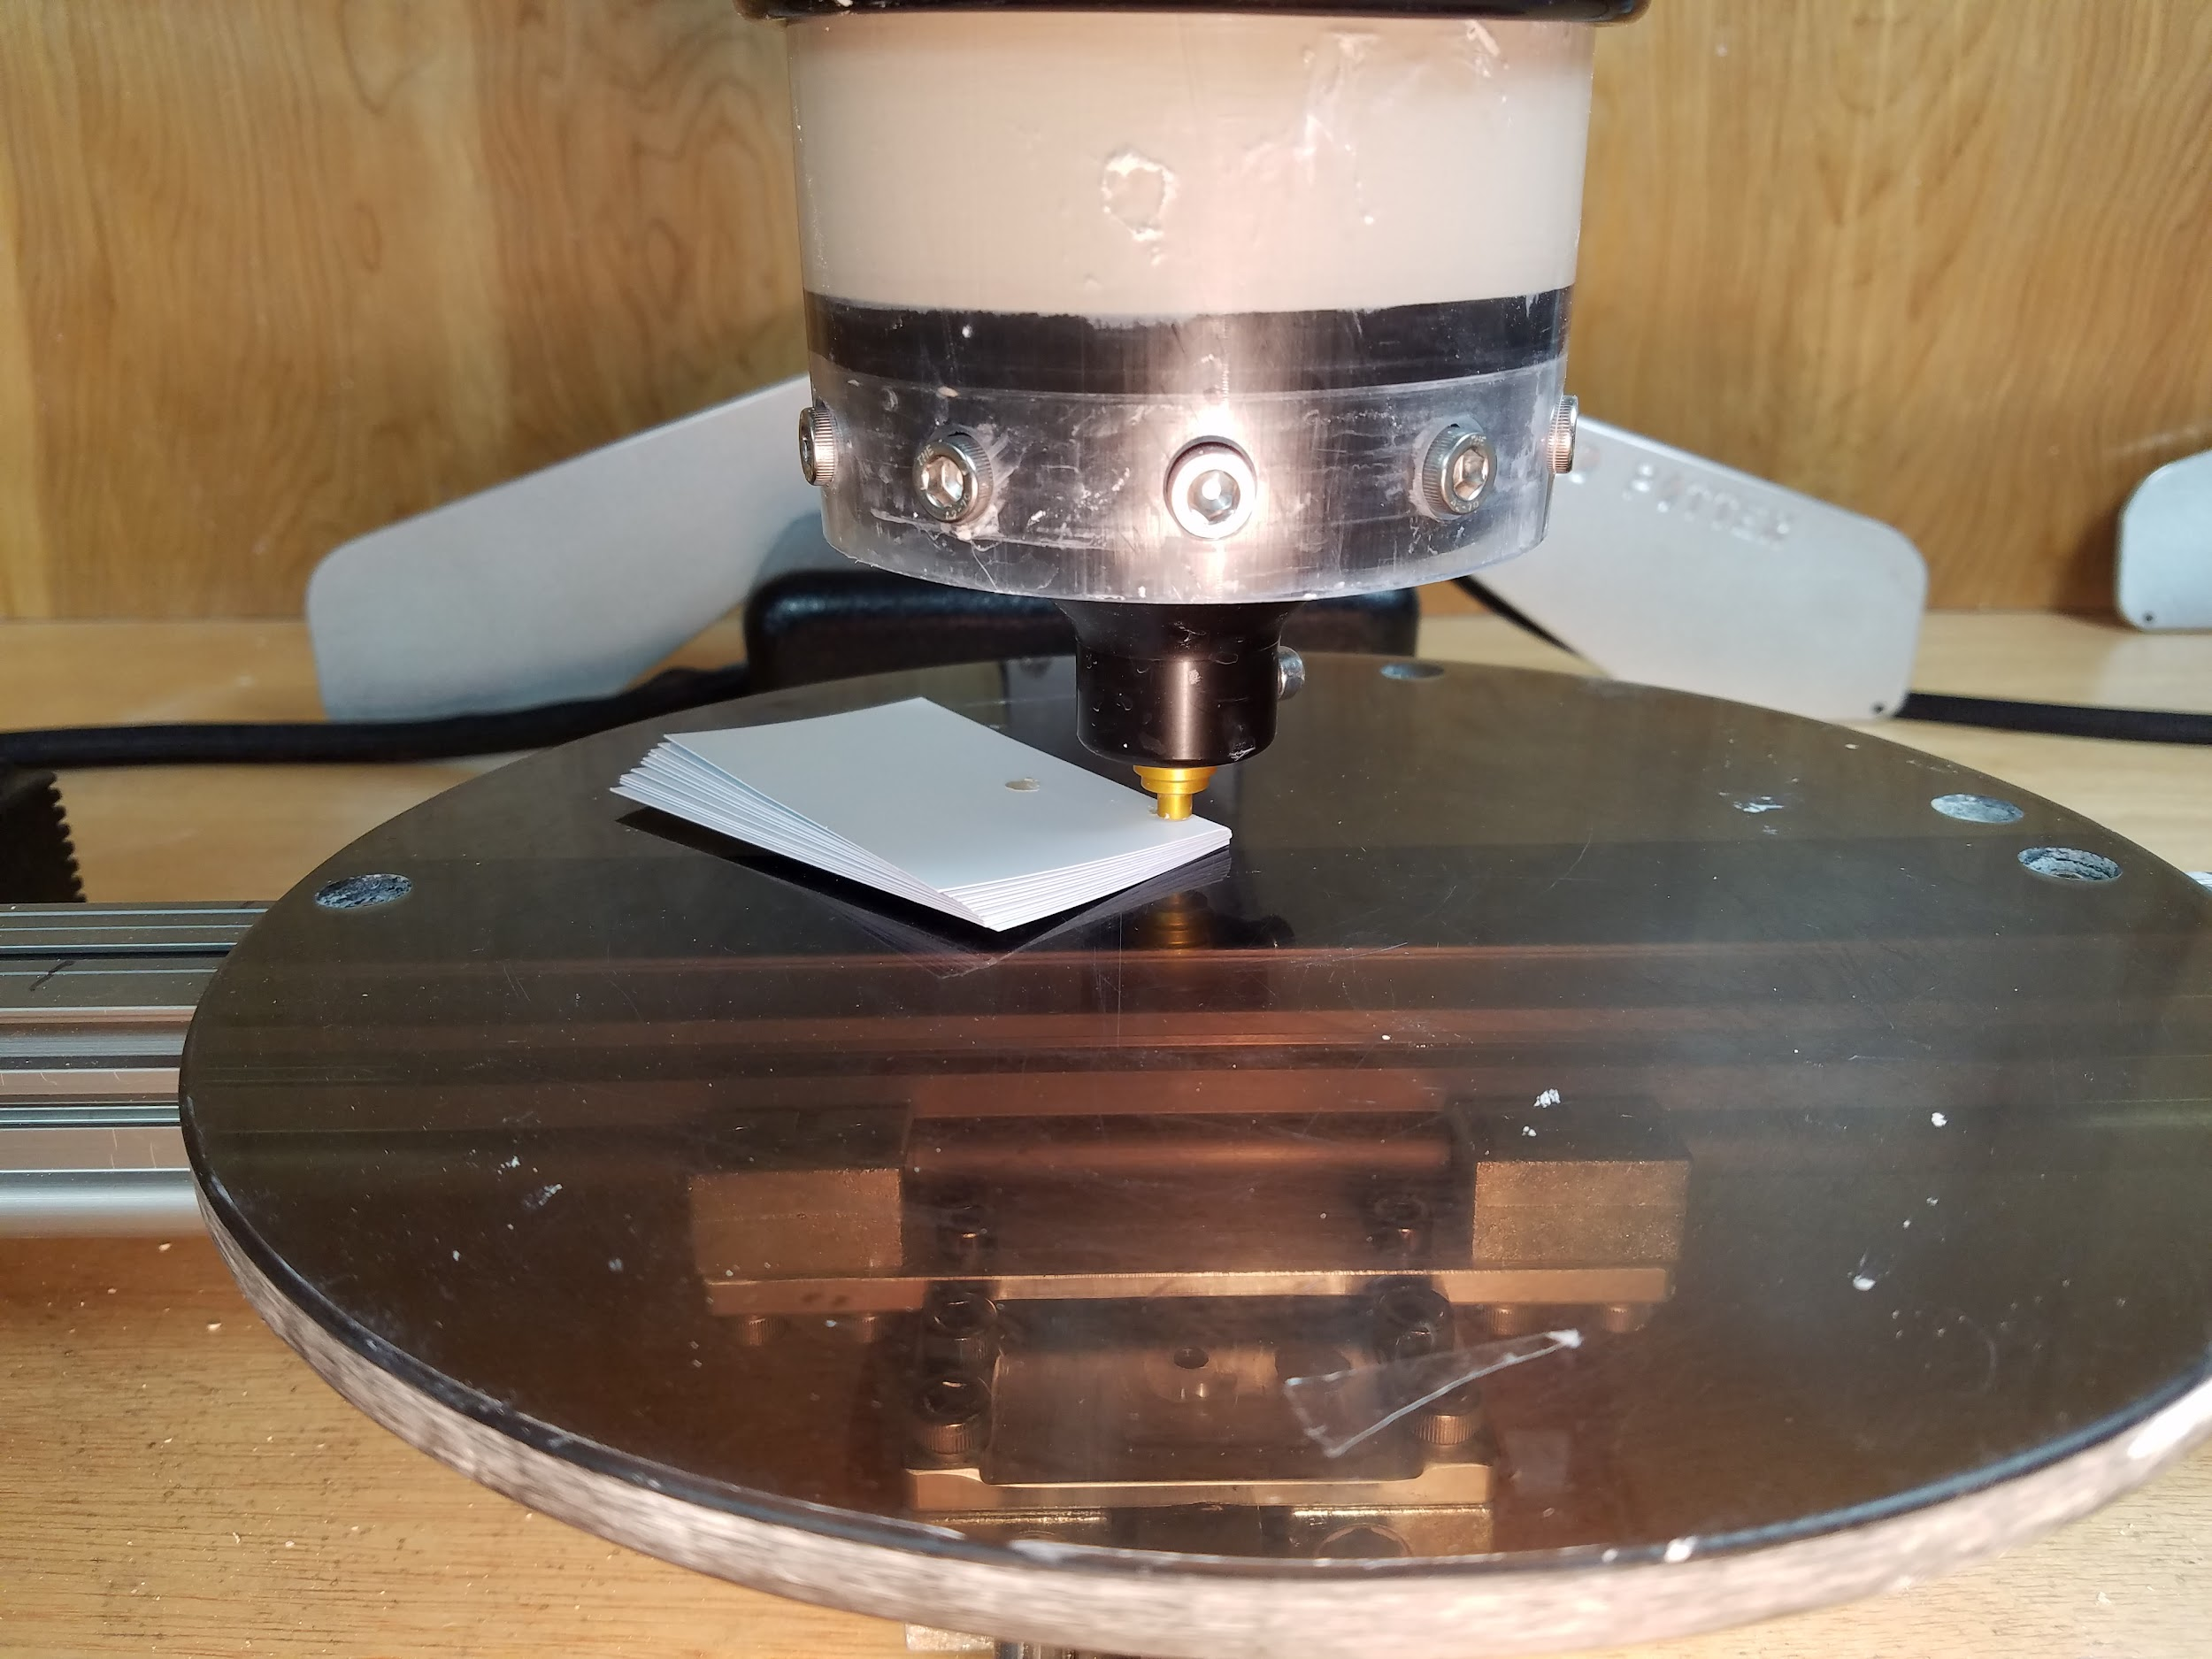

Caution

1. Do not crash the extruder into the bat. (Follow the above instructions.)

2. Do not turn the Acme screw on the extruder by hand at any time to unload the extruder. You could damage the gearbox. Unload the pressure by using the Retract file, see above.

Slicing Program, Simplify3D
We recommend Simplify3D as the primary slicing program. There are several reasons why we recommend this program including ease-of-use, good user interface, and great support on the internet. However, most importantly, we supply the FFF files for this program. These files have all the information for the individual models we have available. This makes the setup of the printer and the utilization much simpler than trying to figure out the speeds and feeds for the individual nozzles and printer sizes. https://www.simplify3d.com/ Be sure to fill out how you heard about them, from 3D Potter.

9 Micro.FFF: Micro 9
9 Standard.FFF: 9, Pro 9, Super 9
9 XL.FFF: XL 9, XXL 9

Simplify3D FFF files: https://drive.google.com/drive/folders/1dPGVhLVZ13wzqfa5krFOvzi3MS4vp40a

If you do not want to use Simplify 3D, there are screenshots of the settings we use for our Standard FFF file in the link above.

Maintenance

- Keep the Acme screw clean and free from clay and debris. Also keep a good layer of grease on the screw and inside the anti-rotator (see ACME above).
- Keep all the rails clean and free from clay and debris. Wax the rails with good quality cleaner wax. https://www.youtube.com/watch?v=HbQcMEKAvRo
- Make sure the omni wheels are at the correct height above the surface (see Omni wheels above)
- Do not use any chemicals to clean the polycarbonate tube. Only use soap and water.
  - This includes any alcohol or ammonia based solutions such as most common glass cleaners.
  - Petroleum based substances like oils or mineral spirits will also damage the tubes causing fractures.

Assembly Procedure

It is highly recommended that you watch the full Box to Pot assembly video. This video covers the entire process of unboxing the printer, assembling it, and running your first print.

Remove all printer parts from the box. Some parts, such as the RAM driver, may be inside a cut out section of the foam. The white ABS screw guard is a long thin sheet of plastic that can be hidden in between foam layers.
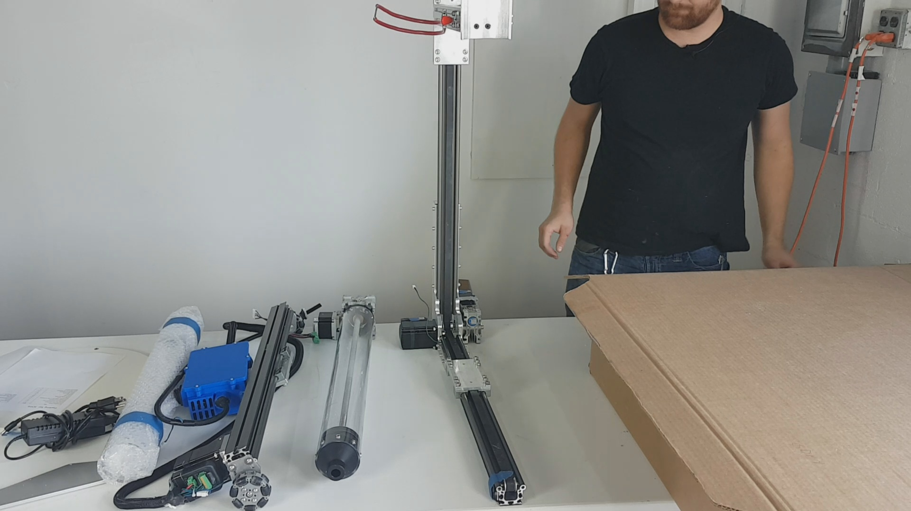

Remove masking tape from motor connections and all 3 limit switches carefully; one limit switch and motor on each rail.
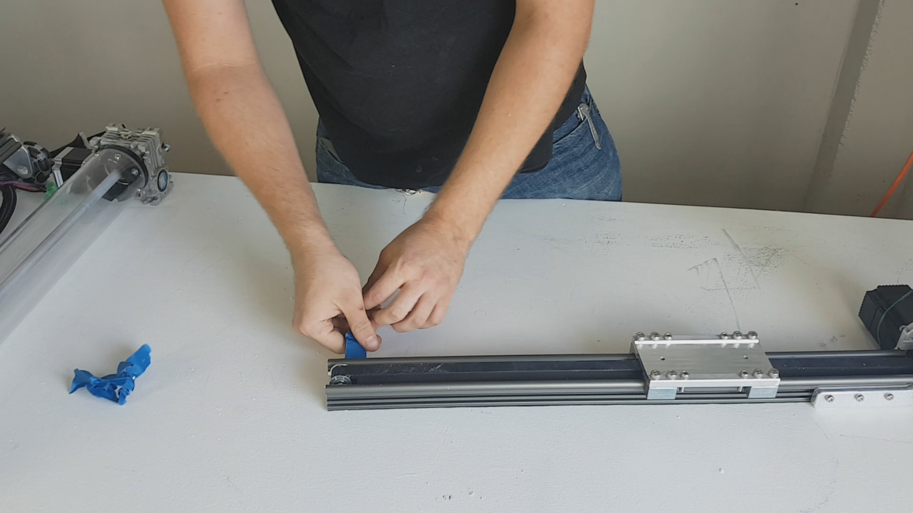

Remove the four screws on the back of the machine. Move the backplate into position, reinstall the screws to secure the backplate. Tighten the screws in an X pattern, opposite sides.
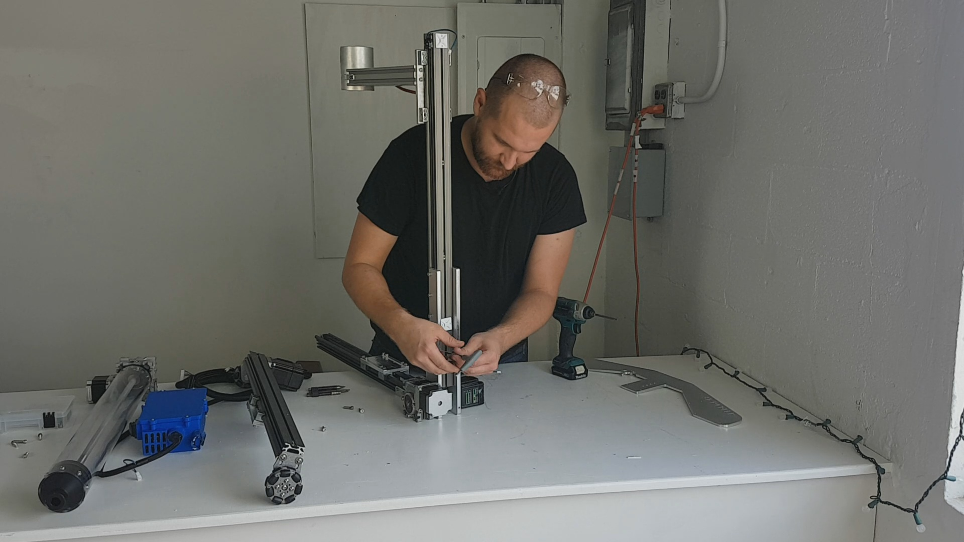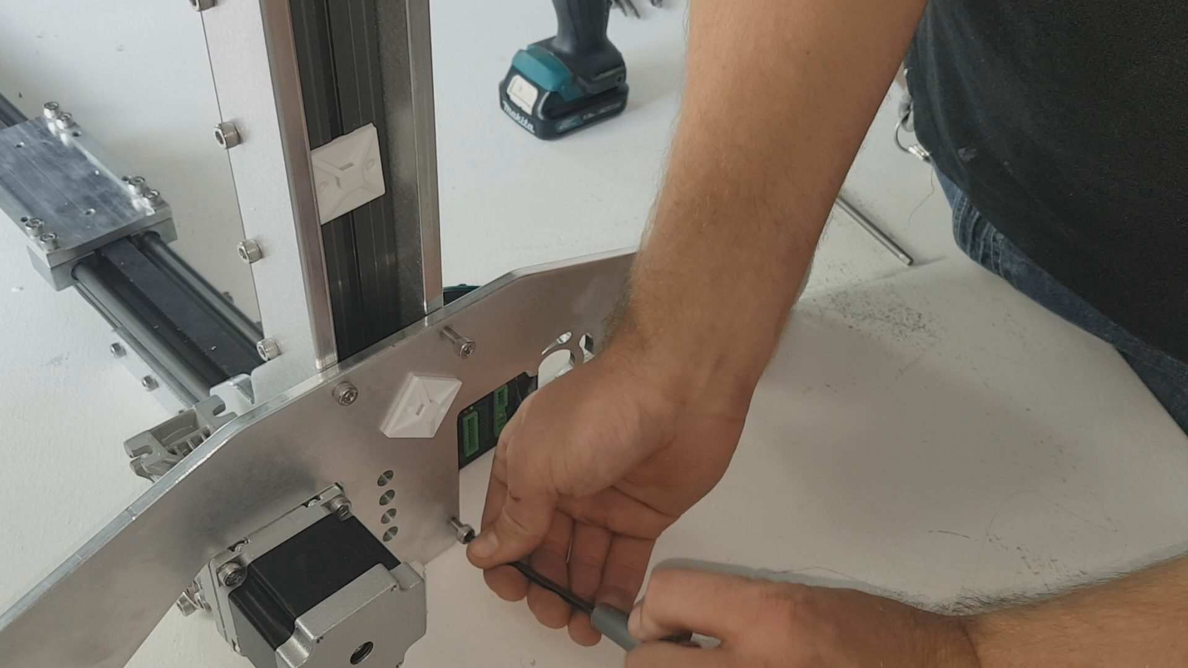

Install the Z motor.
Take out the 4 screws on the Z motor gearbox, slide in the motor while lining up the keyway, and reattach the four screws.
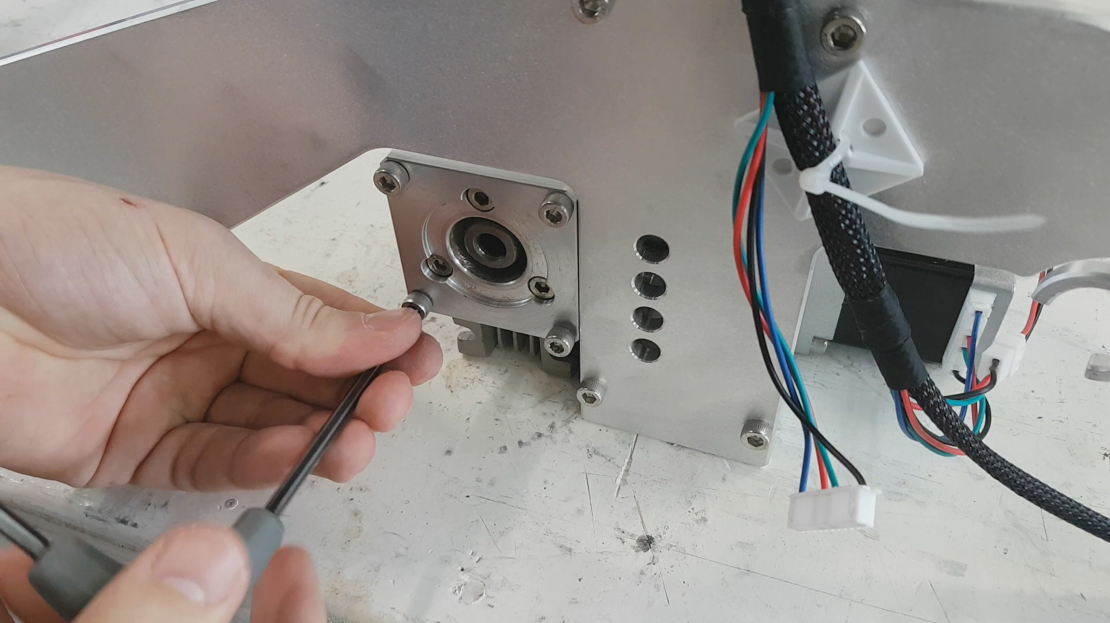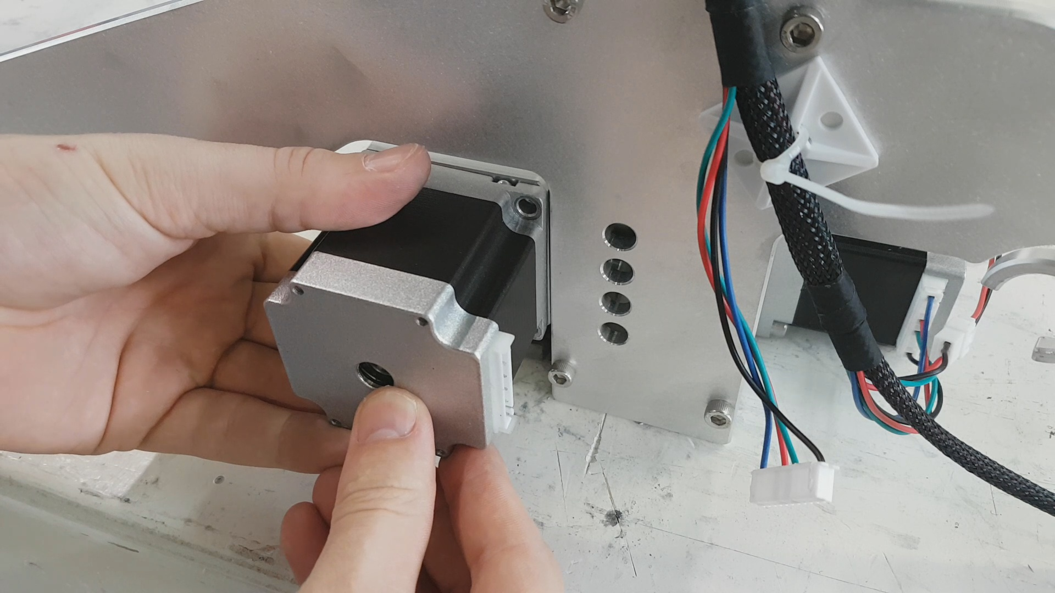
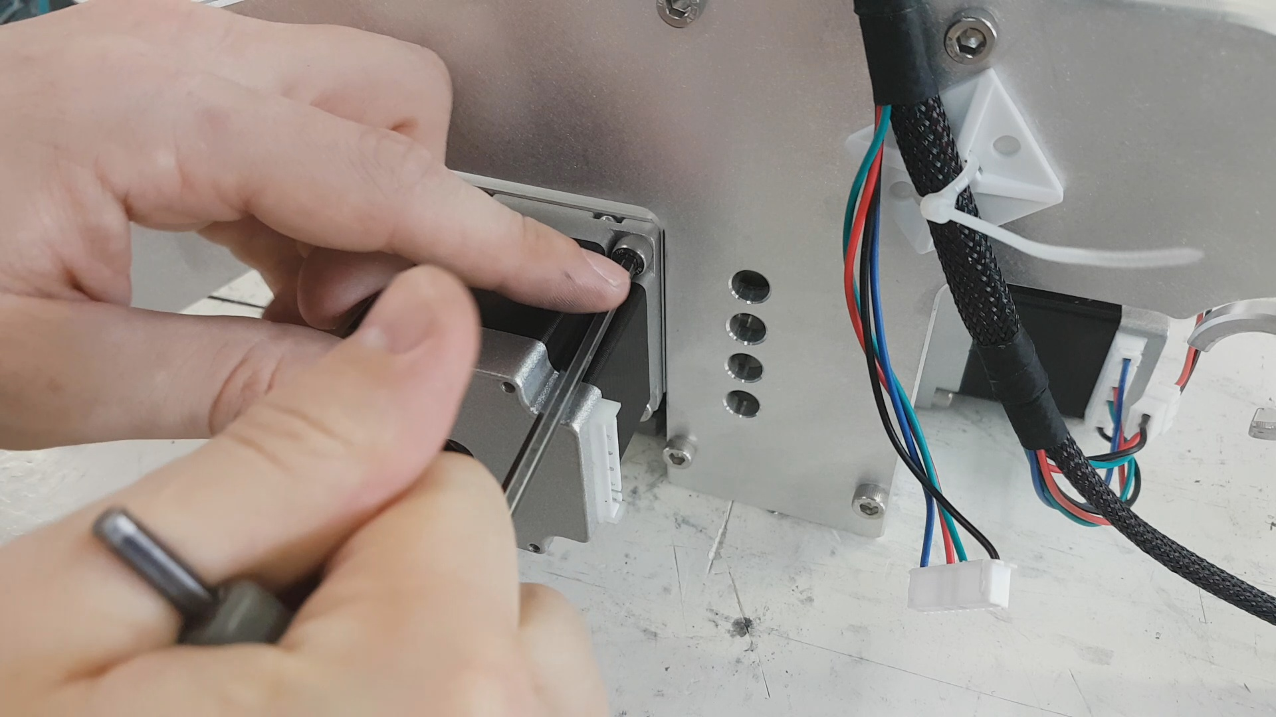

Install the electronics case on the back of the Z rail. The screws are on the case, ready for installation.
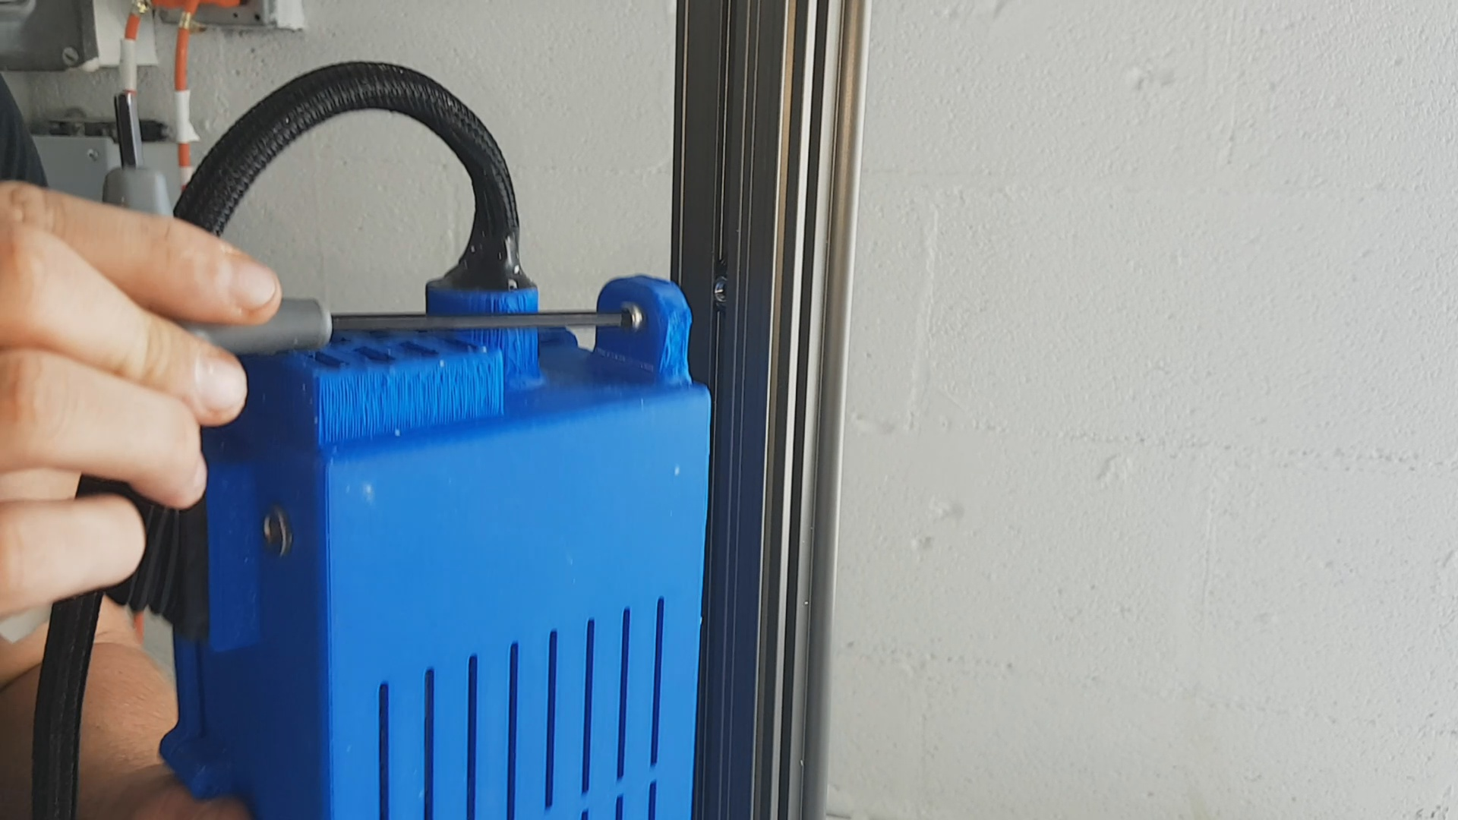

Install the X rail.
Insert the wire harness grommet into the securing bracket on the backplate. Untangle the X-rail wire harness, if needed, by twisting the rail so that the cable harness is straight with no twists.
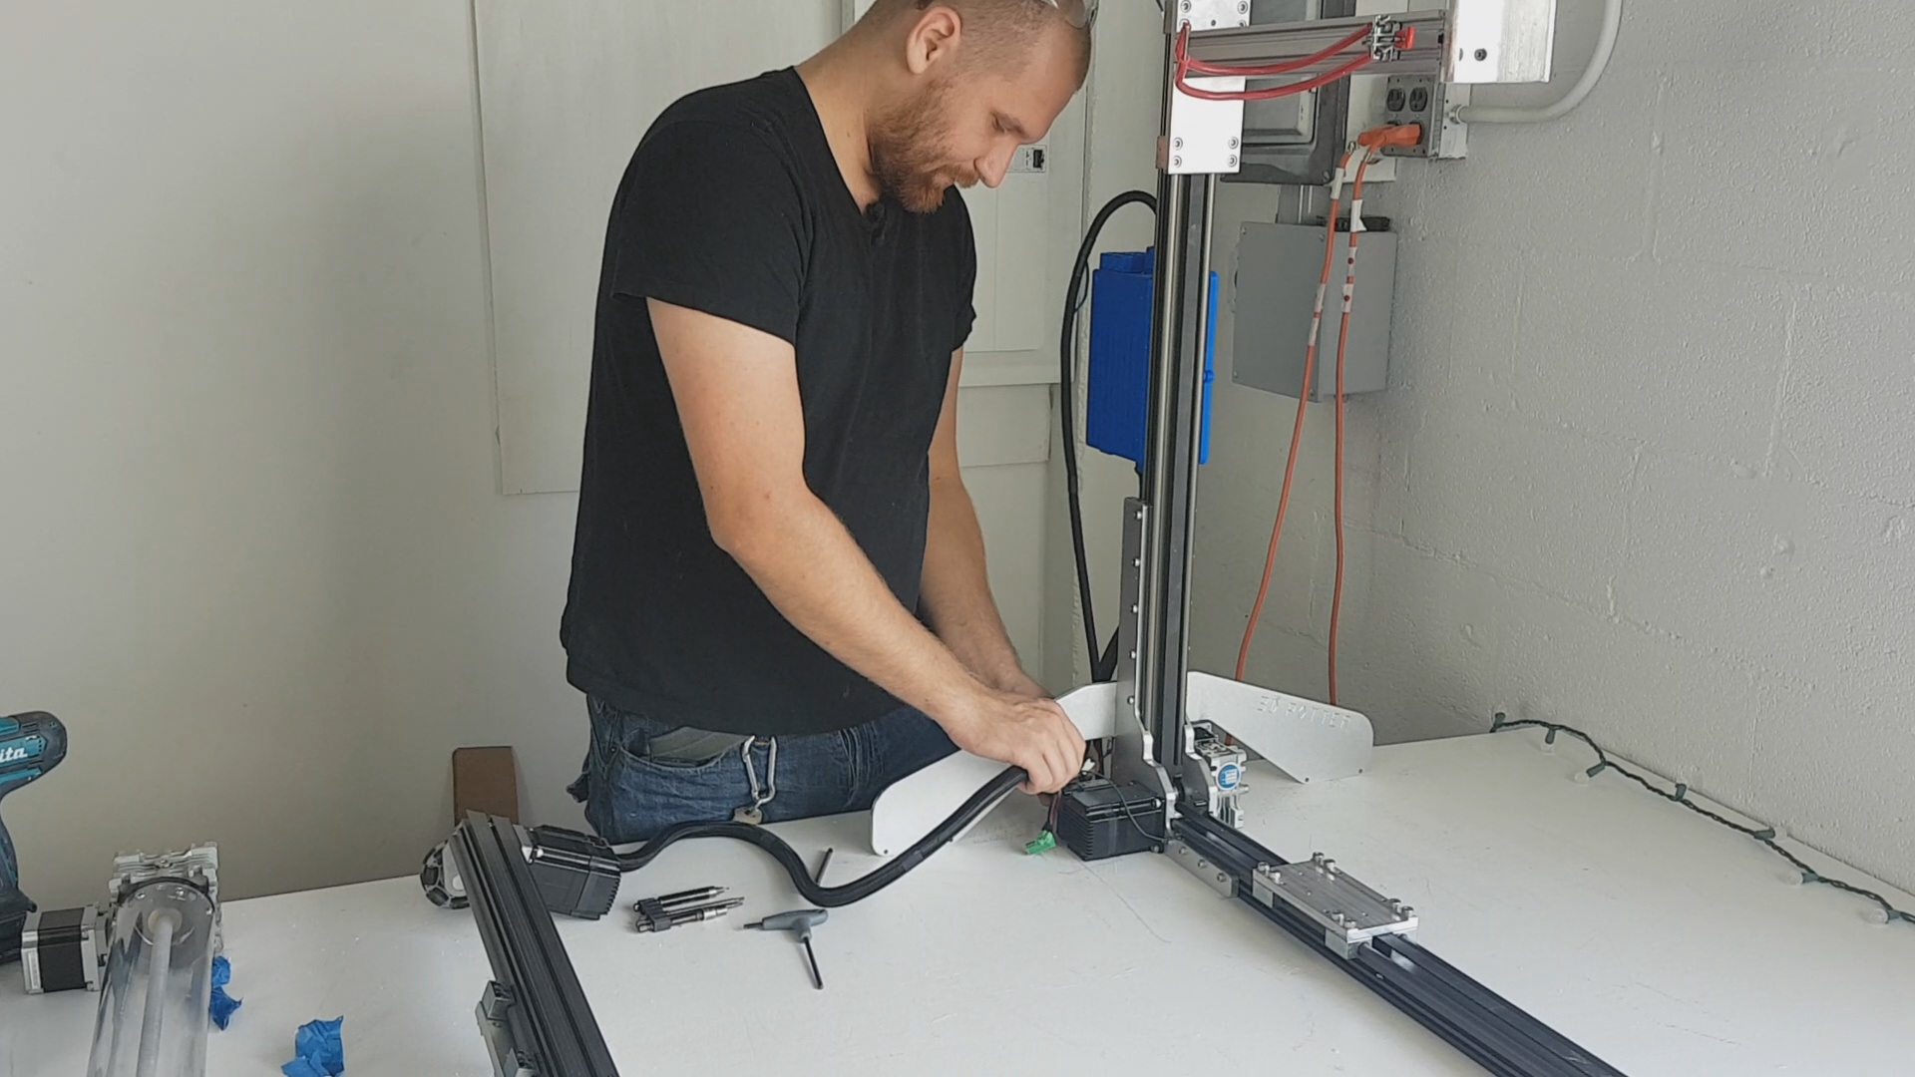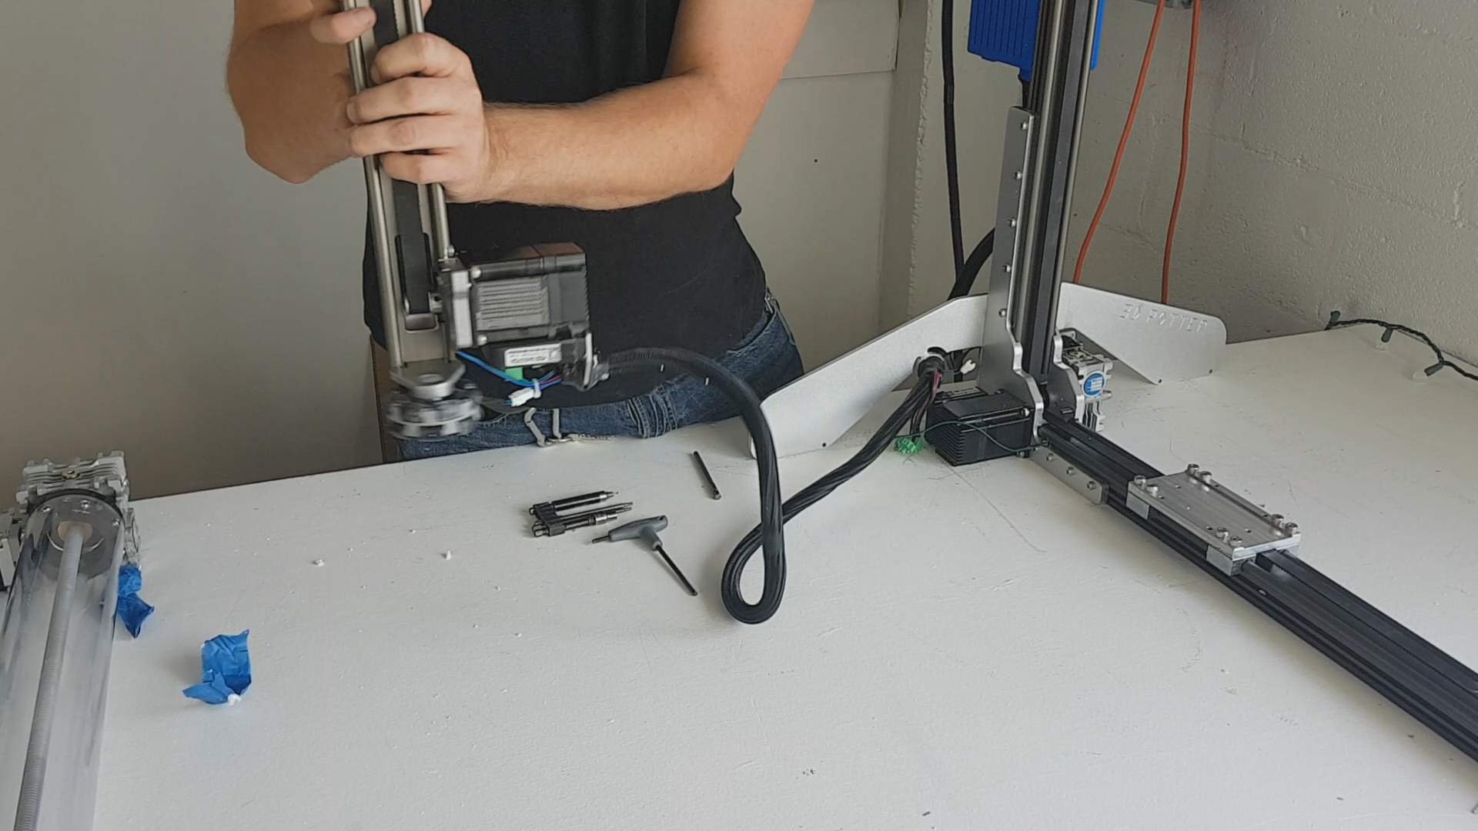

Remove the four screws on the Y rail car. Place the X rail on top of the Y rail, reinstall the screws to secure the X rail. Tighten the screws in an X pattern, opposite sides.
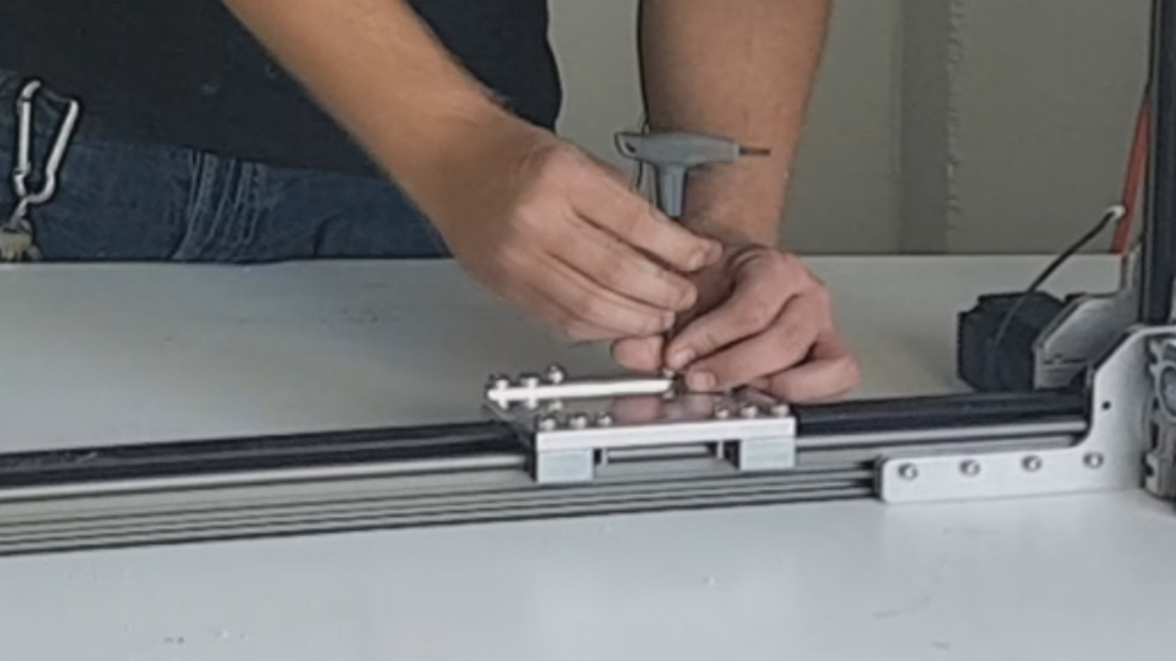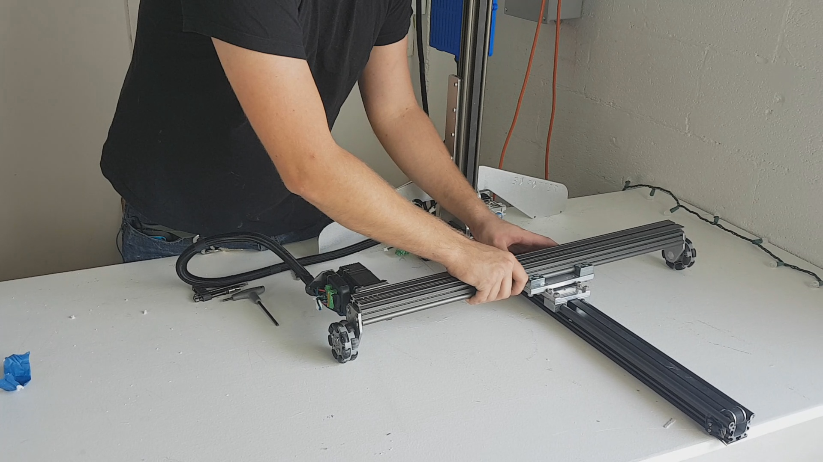

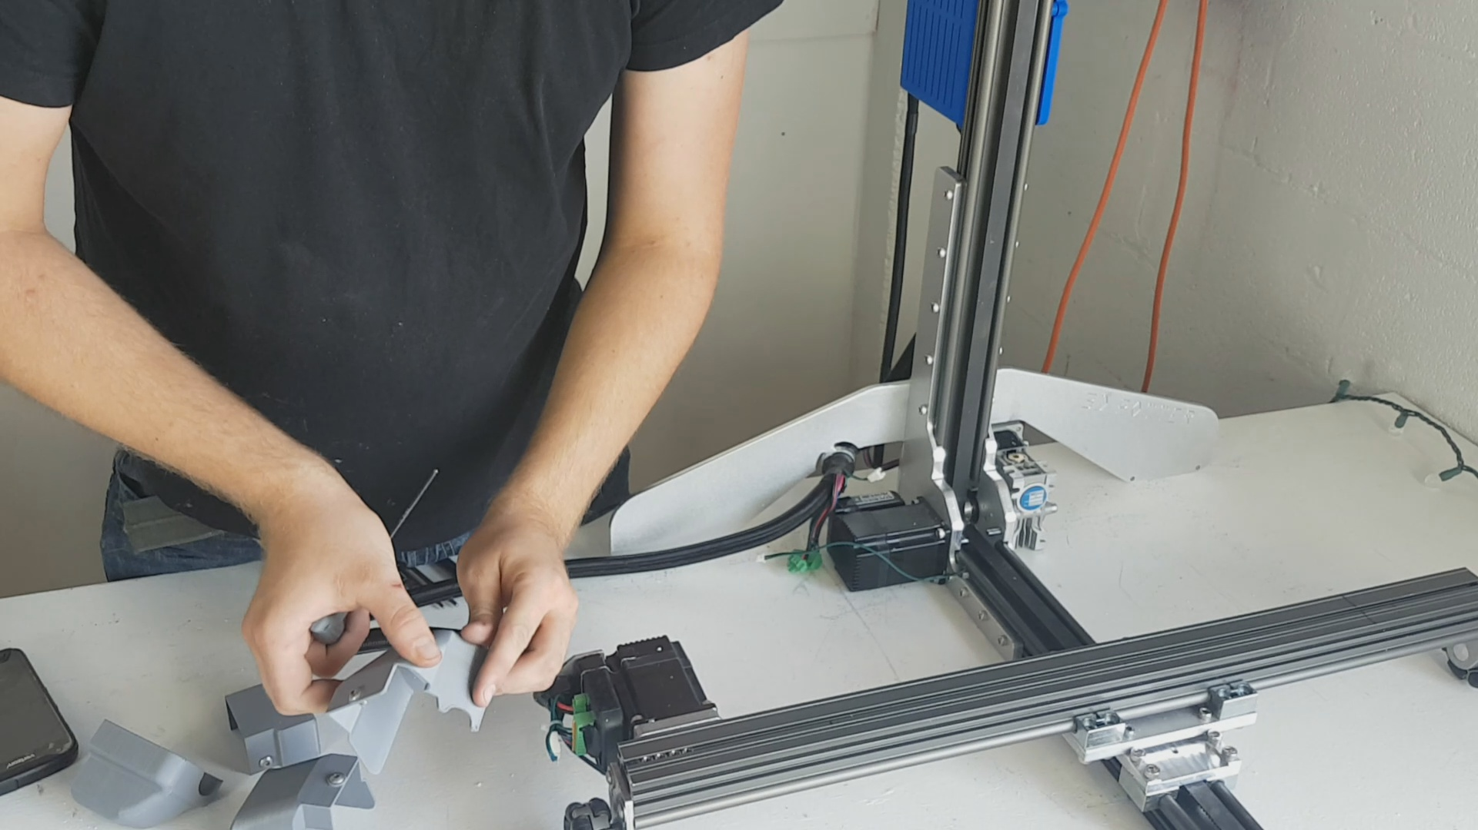
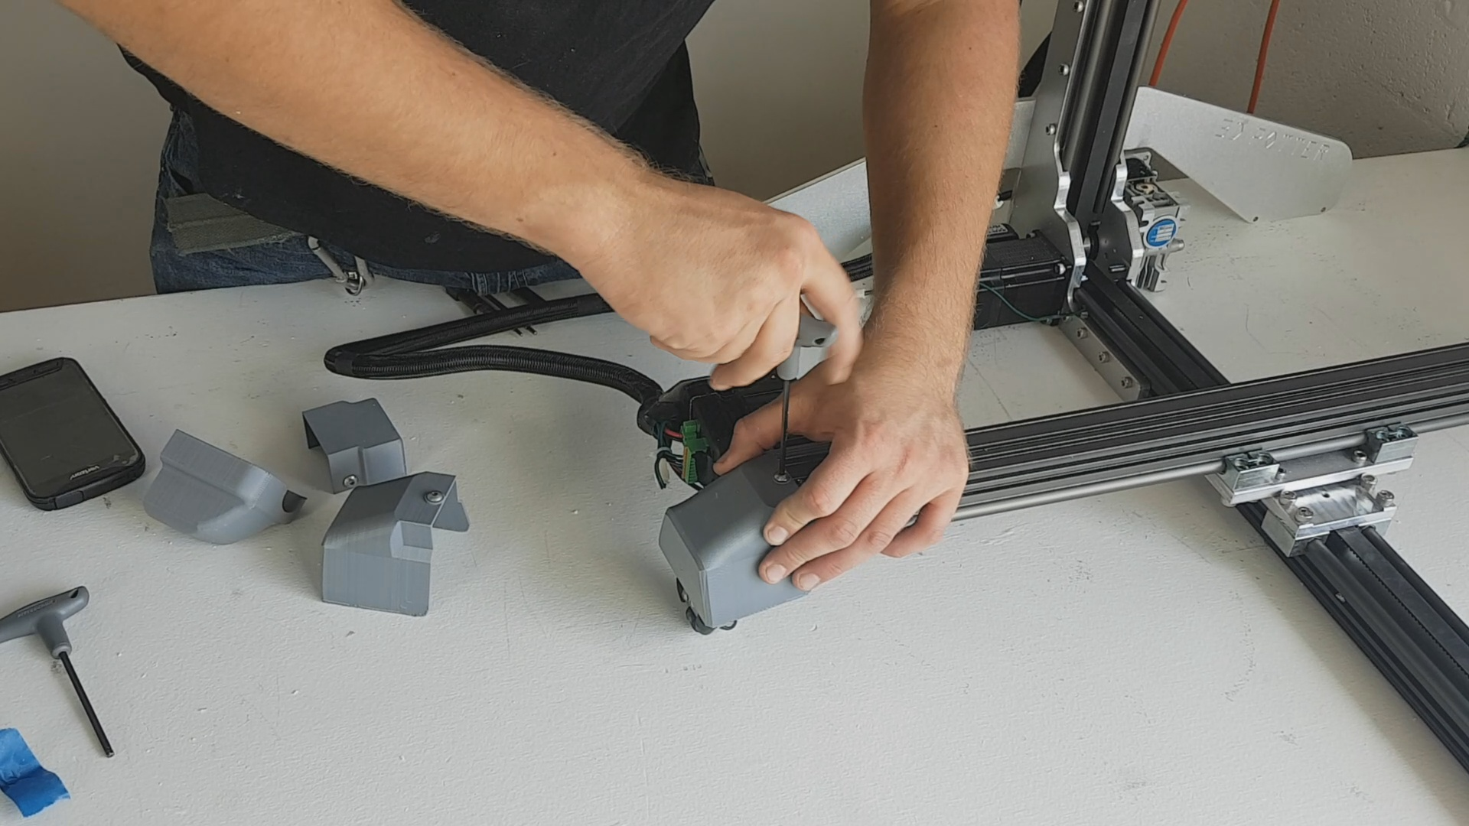
Install the covers. The covers for the machine have screws in them already, secured by masking tape. Covers with no screws have velcro to secure them. The left X rail cover has a cutout on it to allow a wire to pass by easier.
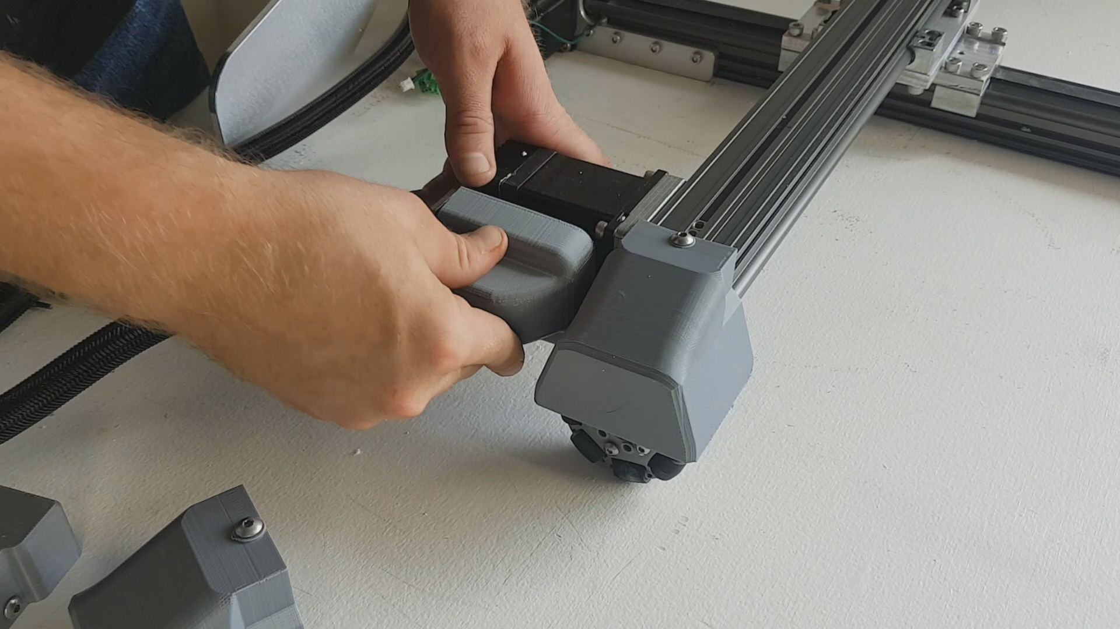
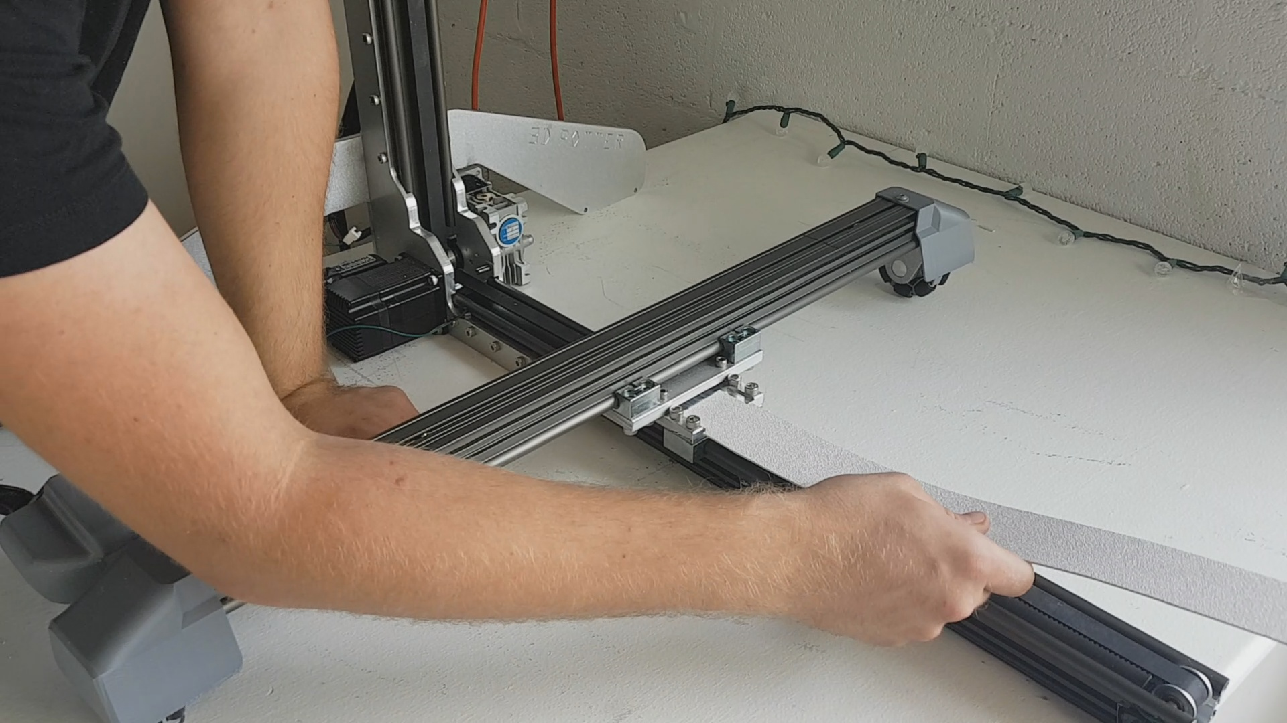
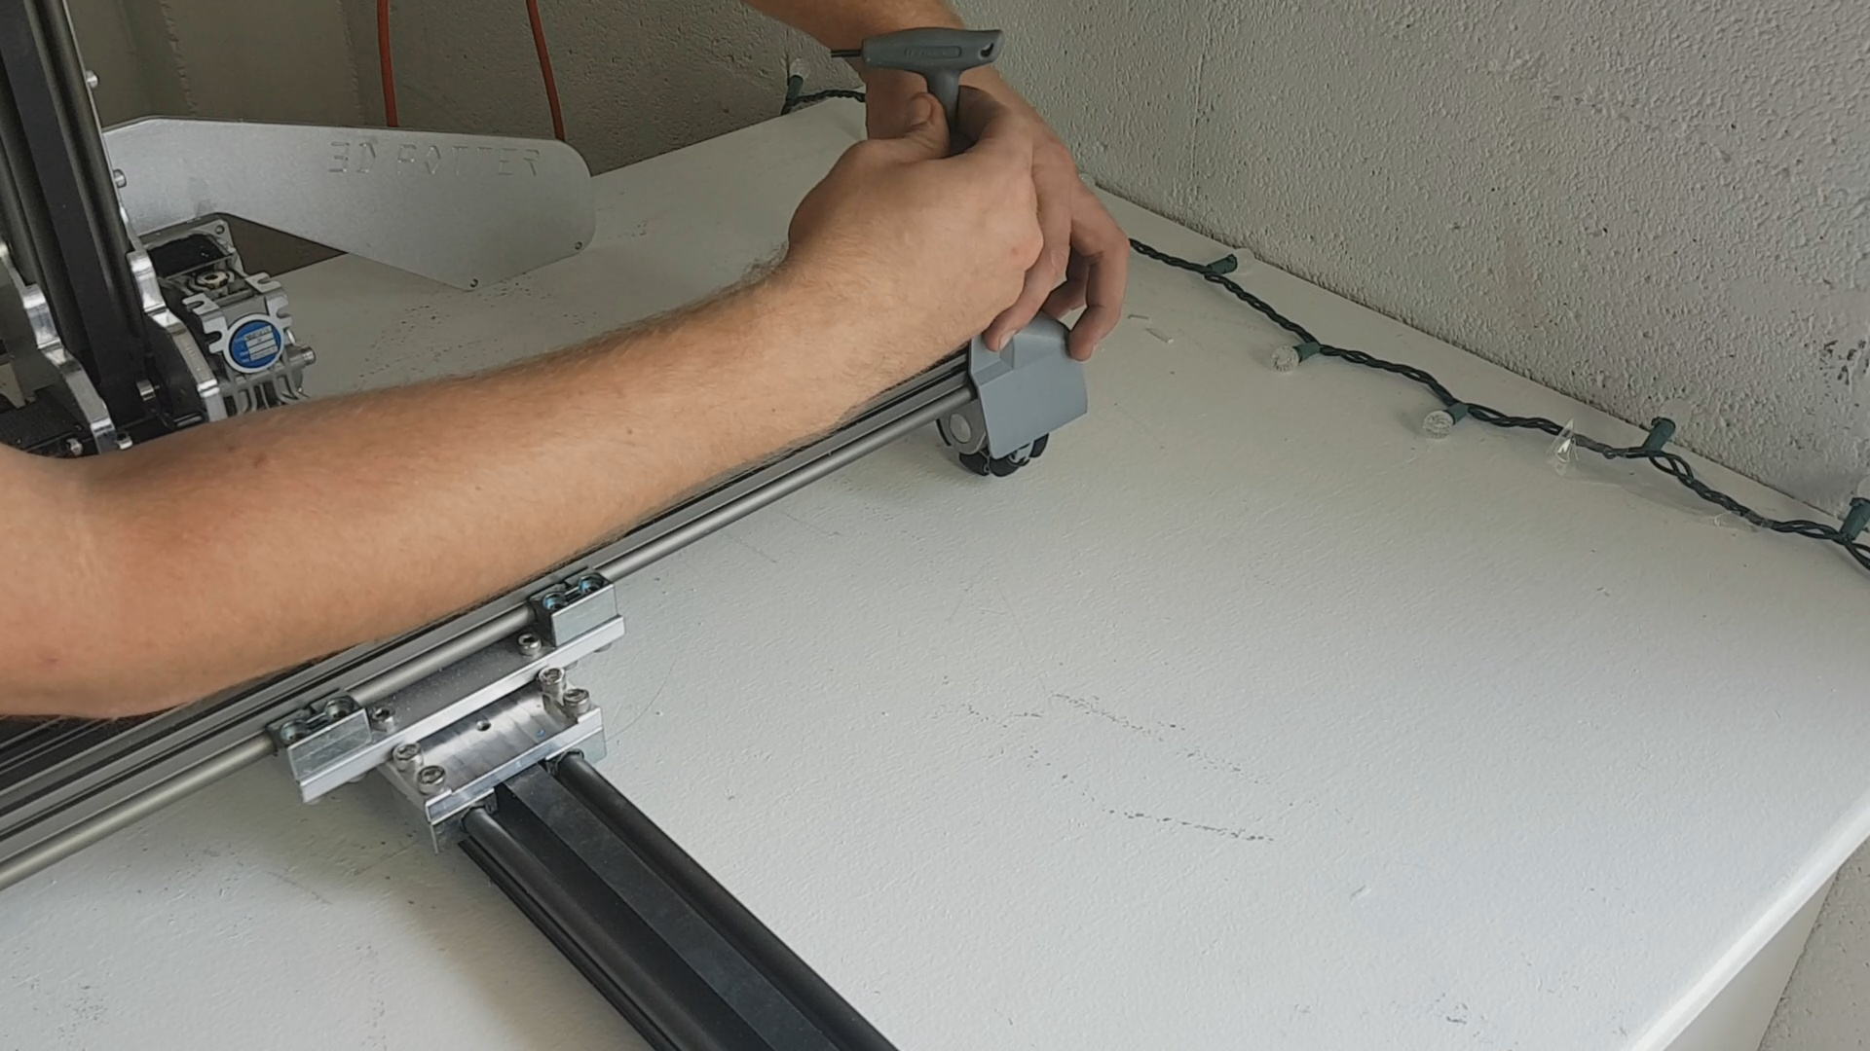
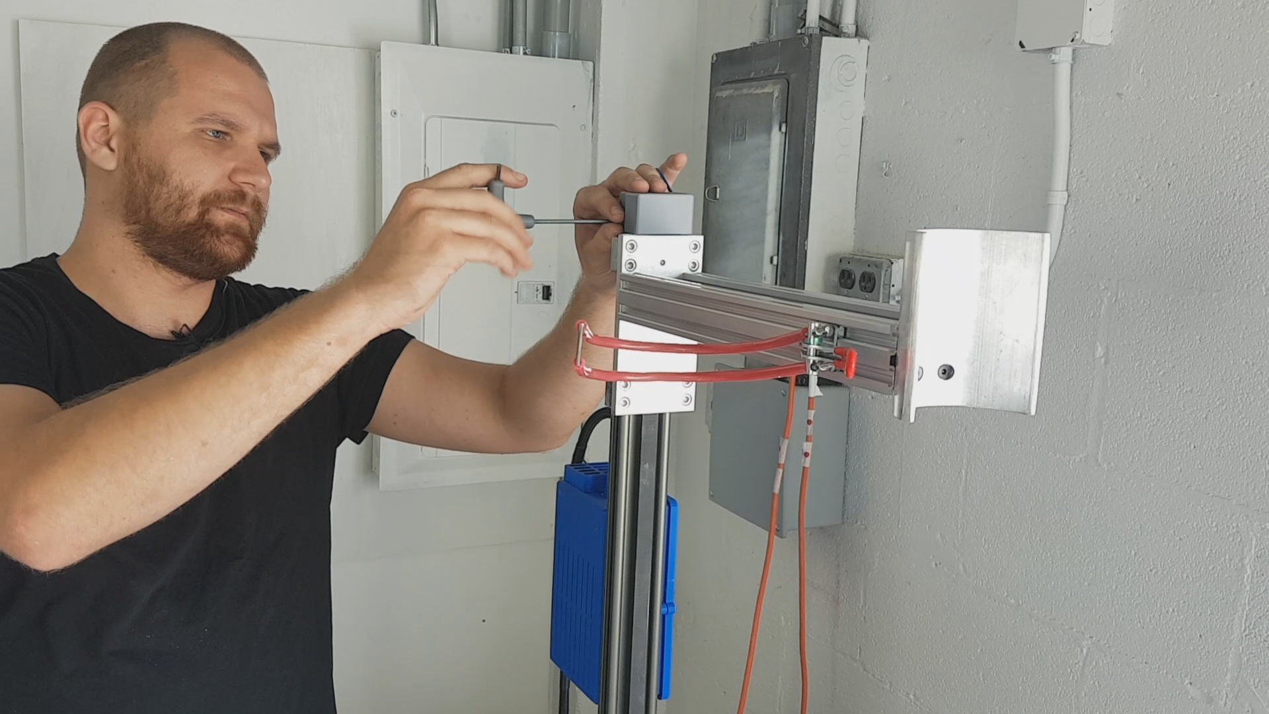
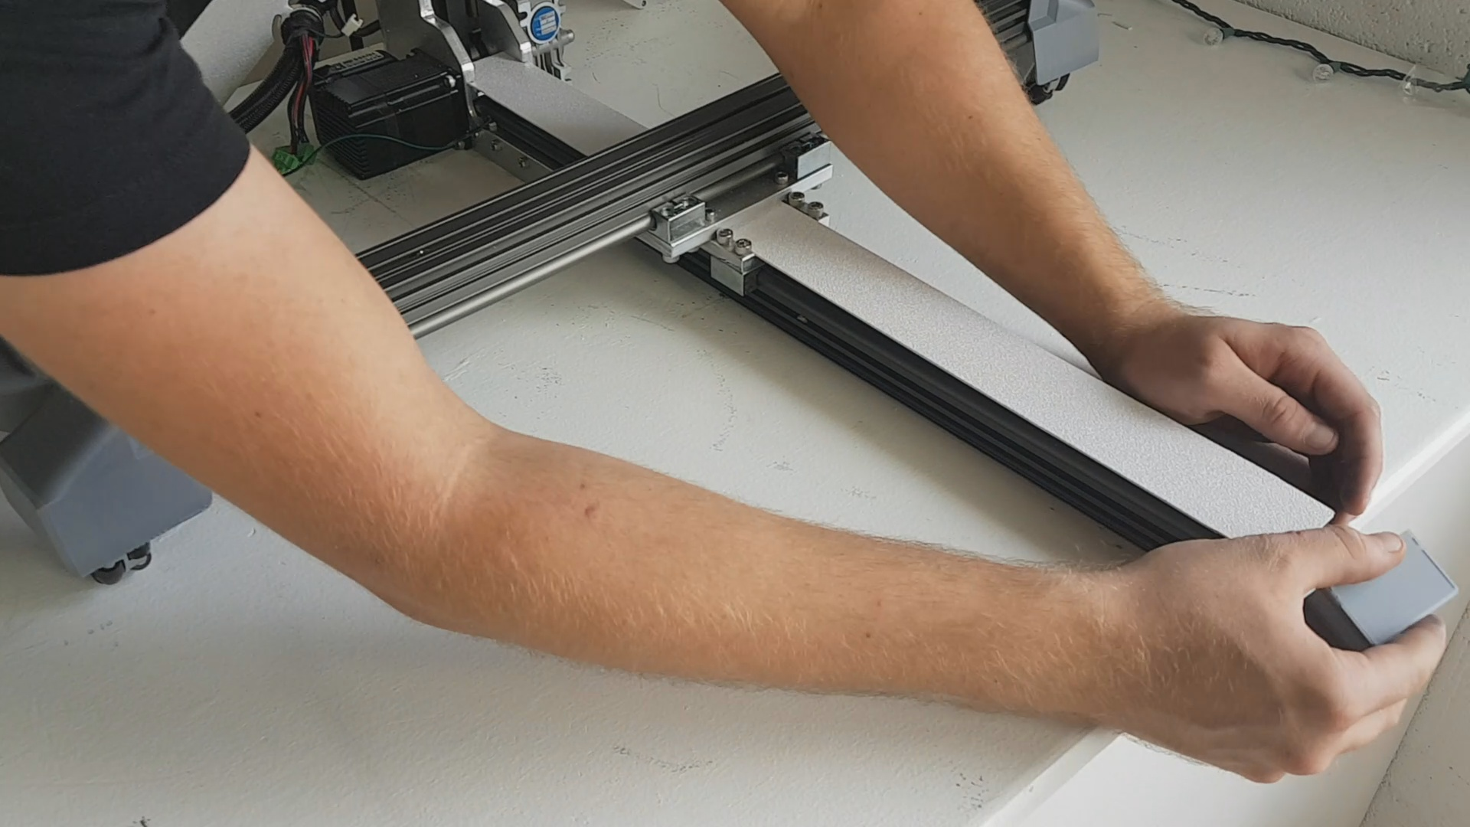

Plug in motors and limit switches. You must plug in all limit switches or the machine can crash into itself. One is connected already (the X motor). The Y and the Z rail limit switches need to be connected. Zip ties should be used to secure the wire harness. Make sure that you plug in the Y limit switch before putting on the black cover.
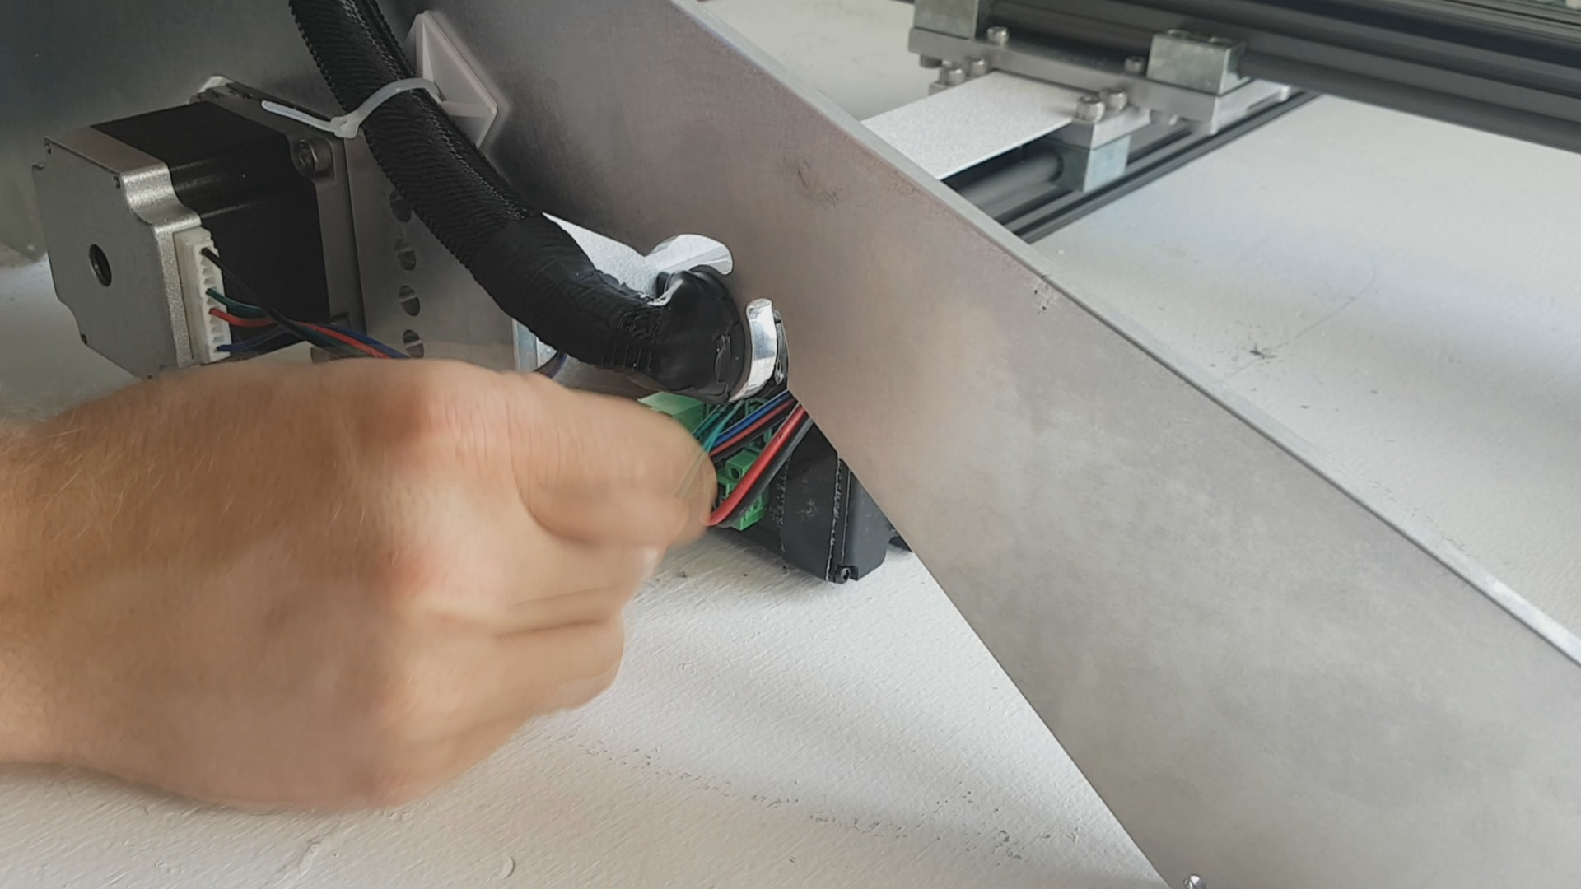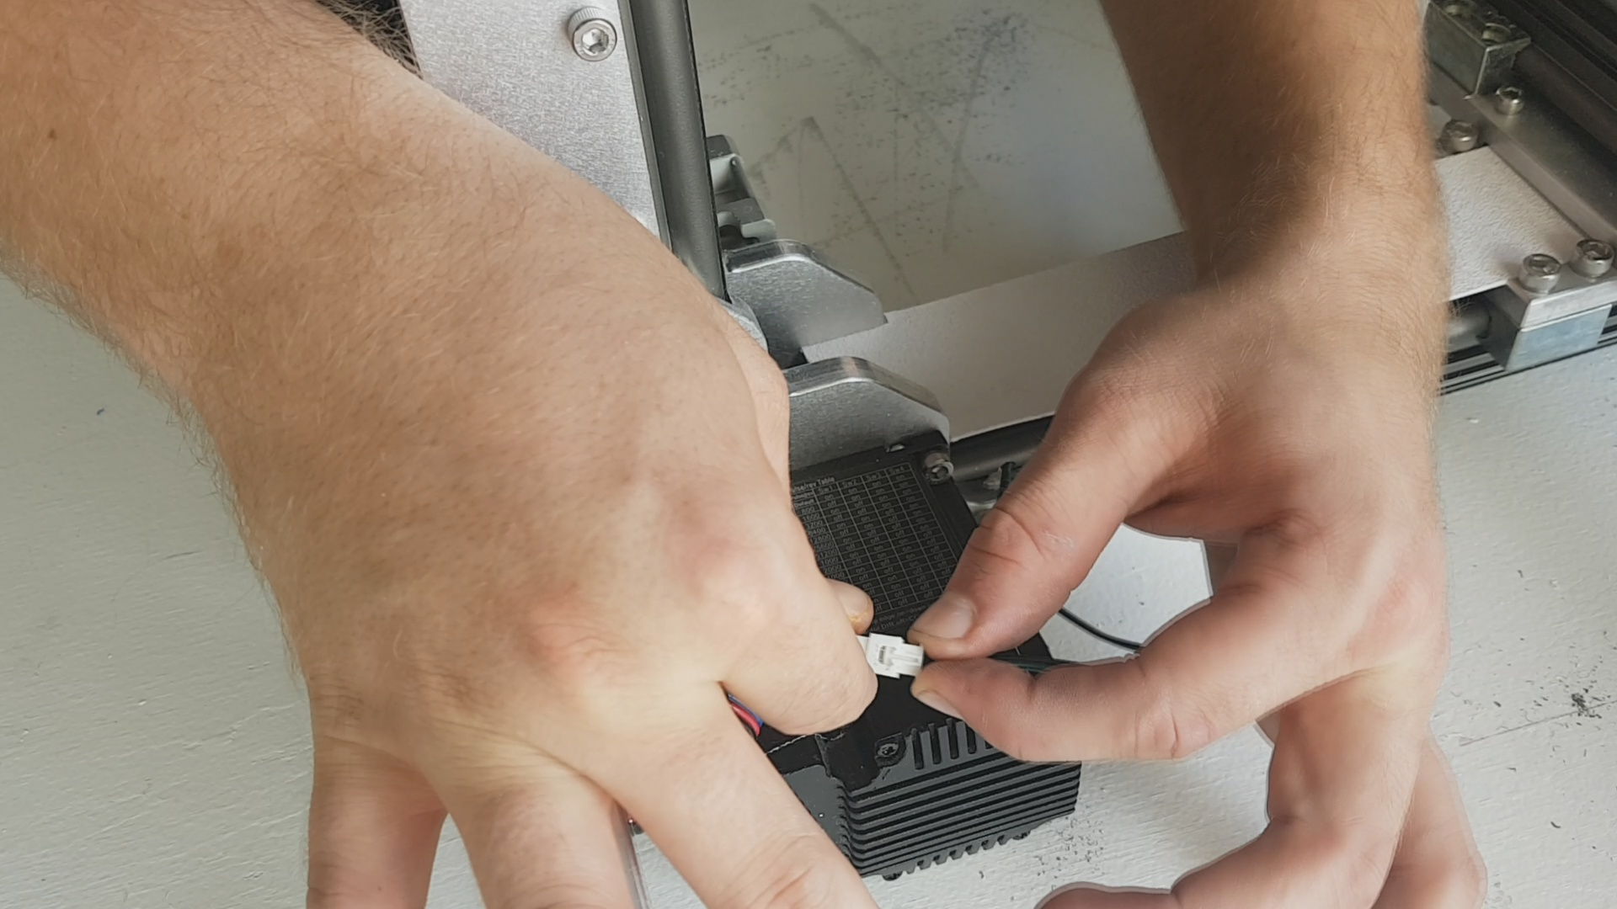
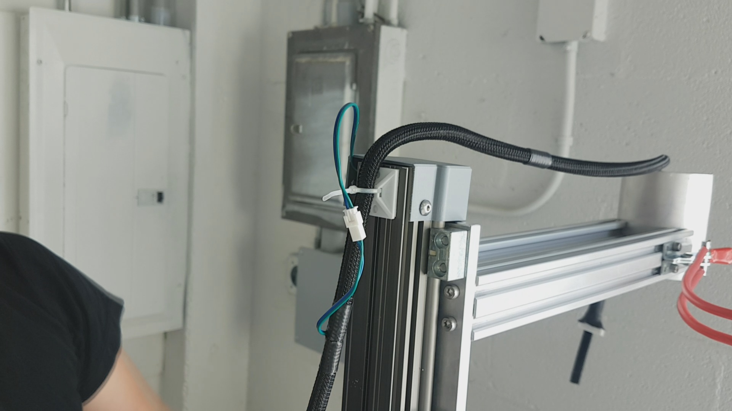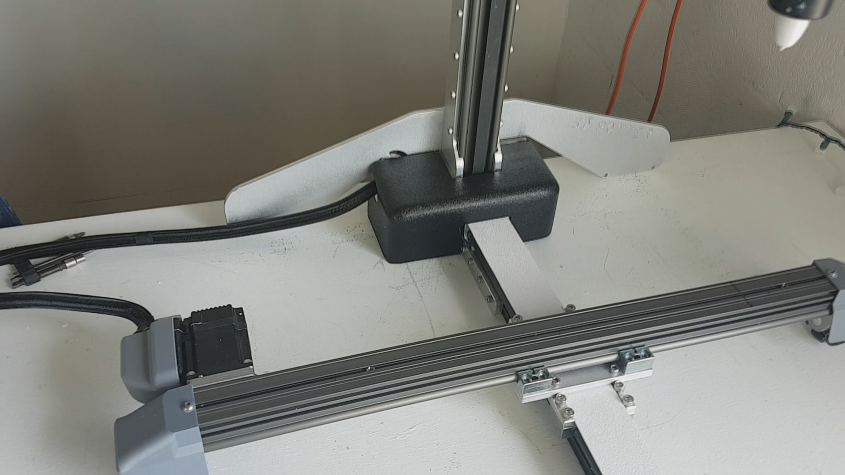

When putting a full extruder onto the machine, make sure the anti-rotator is attached to the extruder (the long square tube). It is attached with two screws which act as pins and are already in the extruder gearbox. When plugging in the extruder, make sure the power is turned off and that the velcro is fully pulled up to ensure a secure connection.
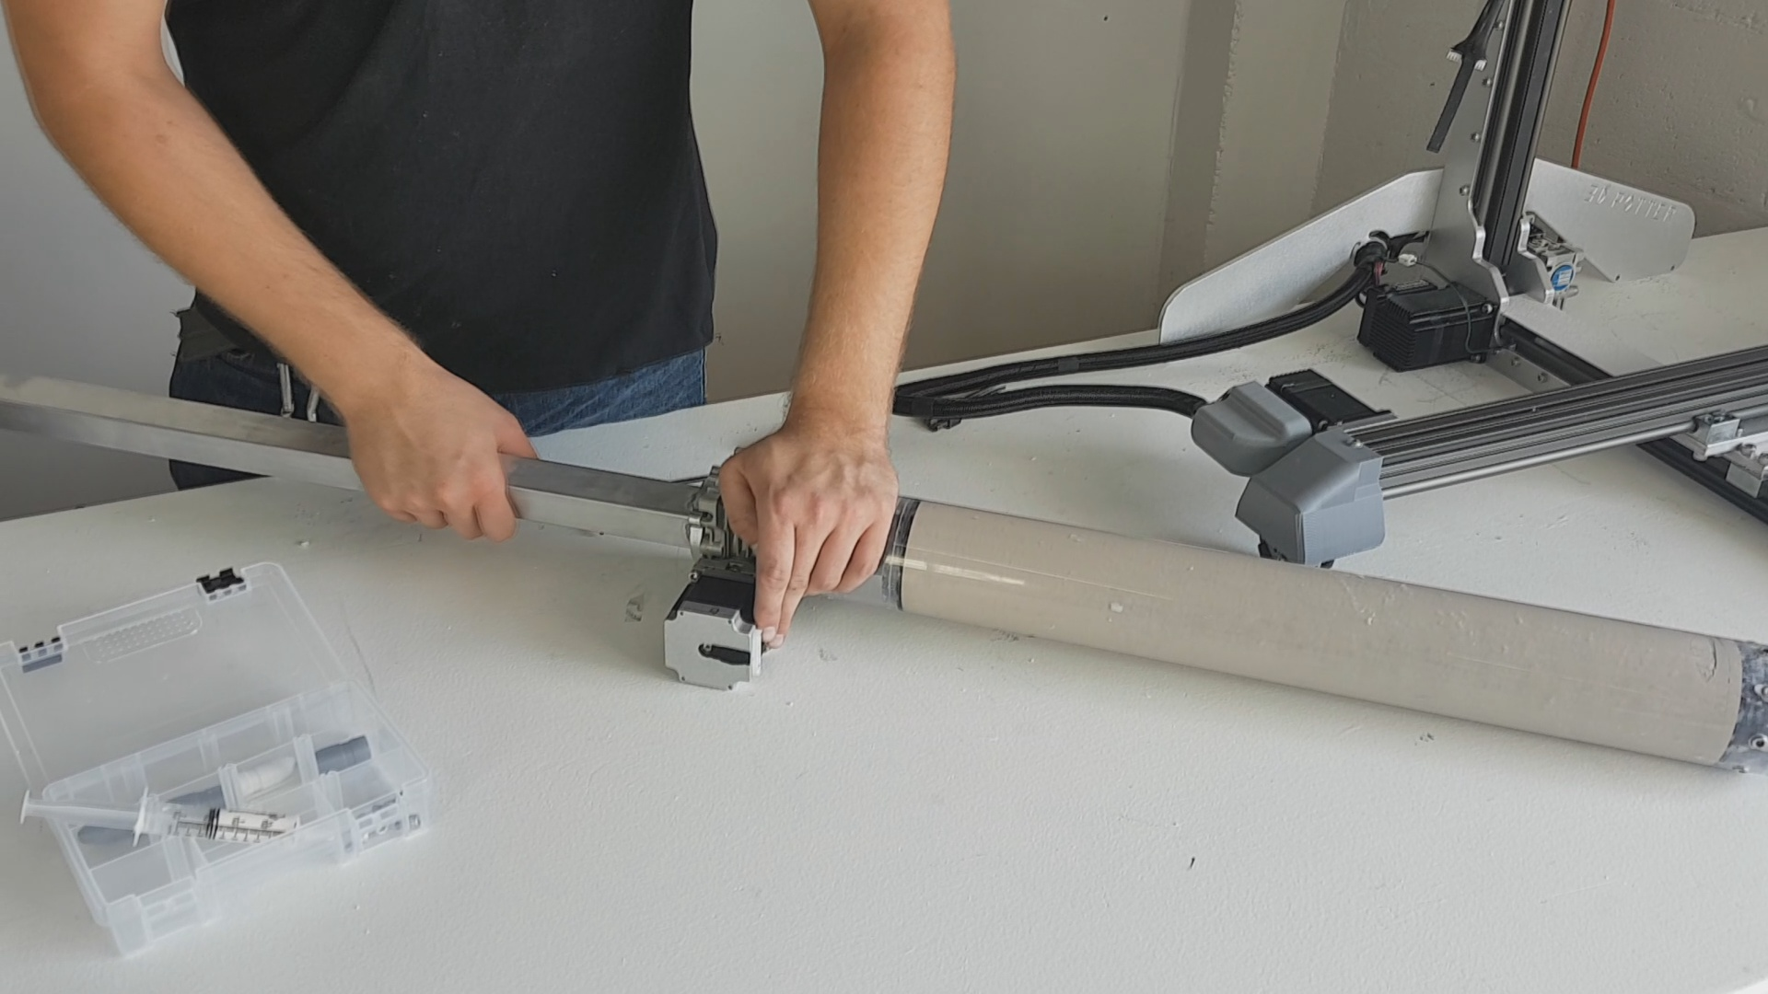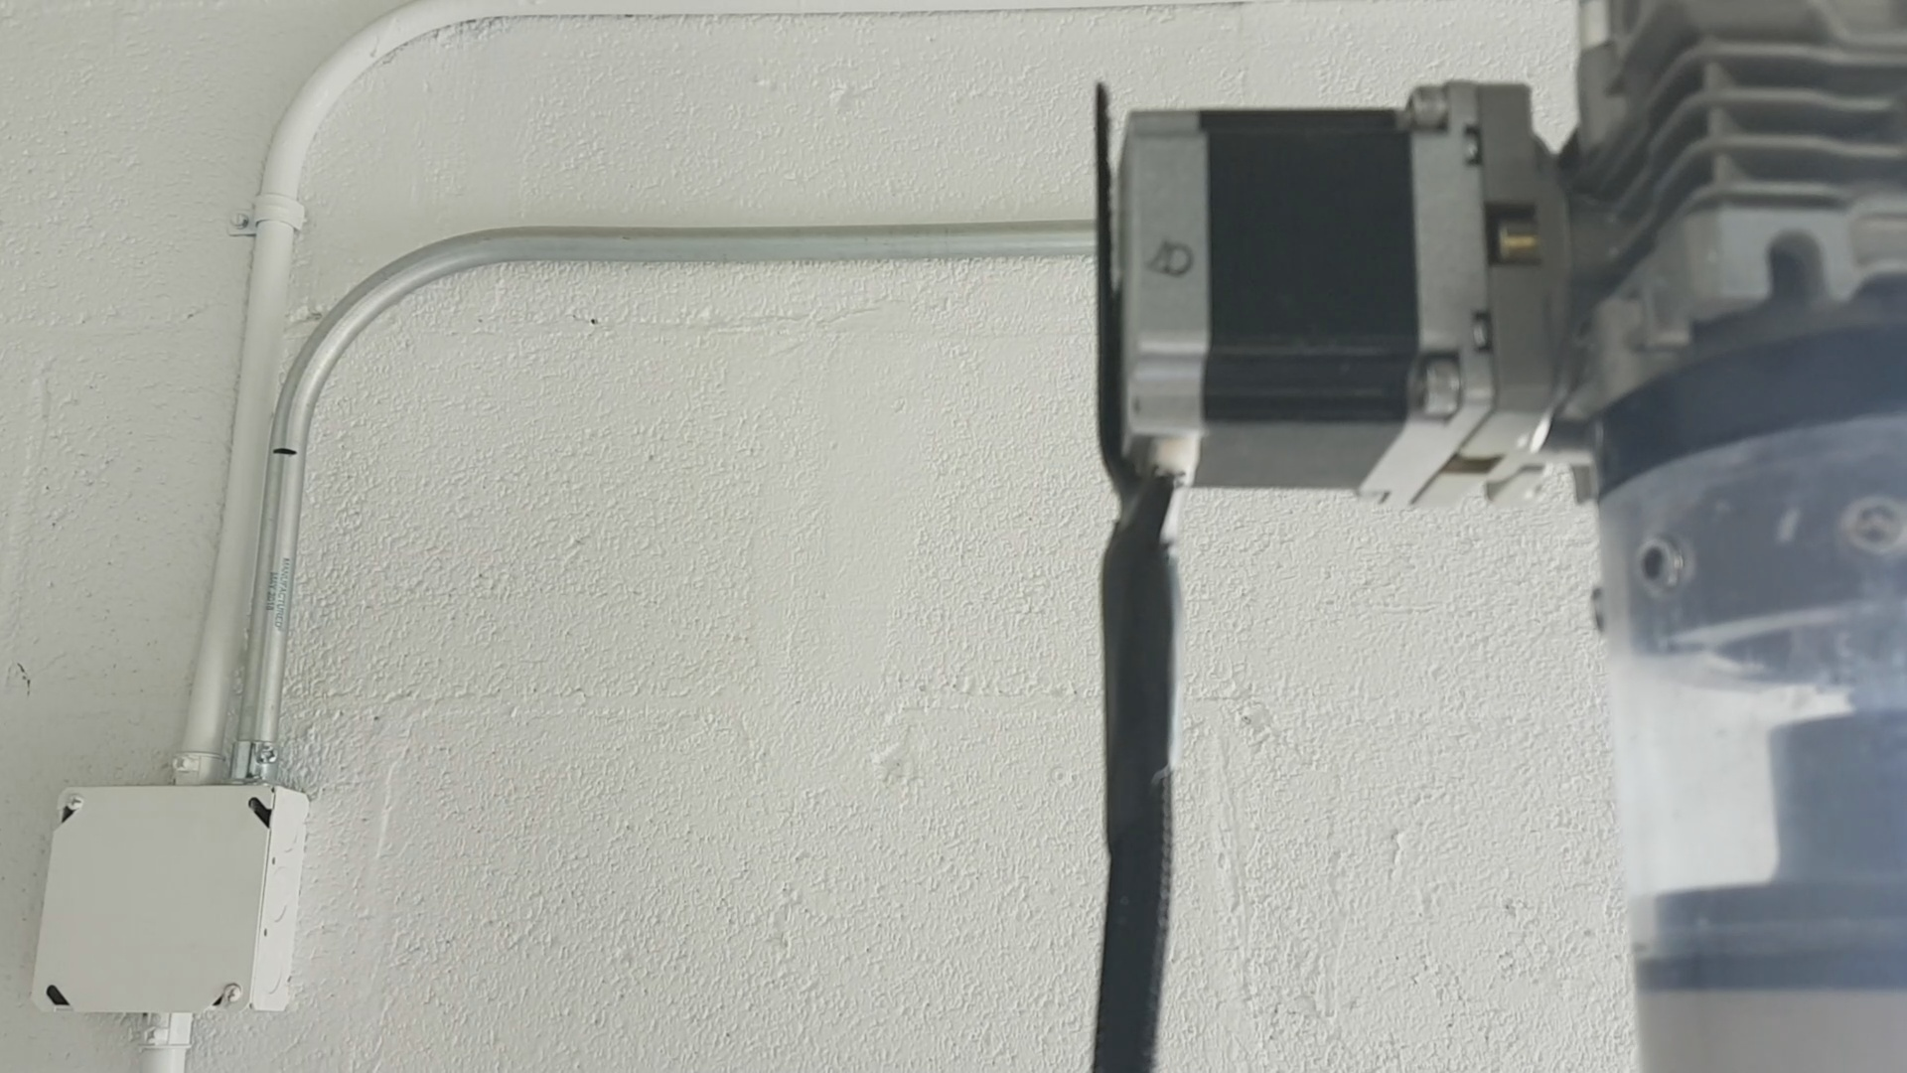

When installing the bat, there is a black mark on the X rail to help you line it up with the center of the rail. There are four square nuts in the X rail. The two outside ones are used to secure the covers. The two middle ones are used to secure the bat.
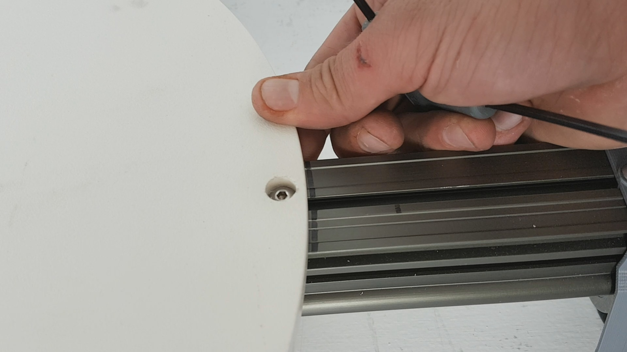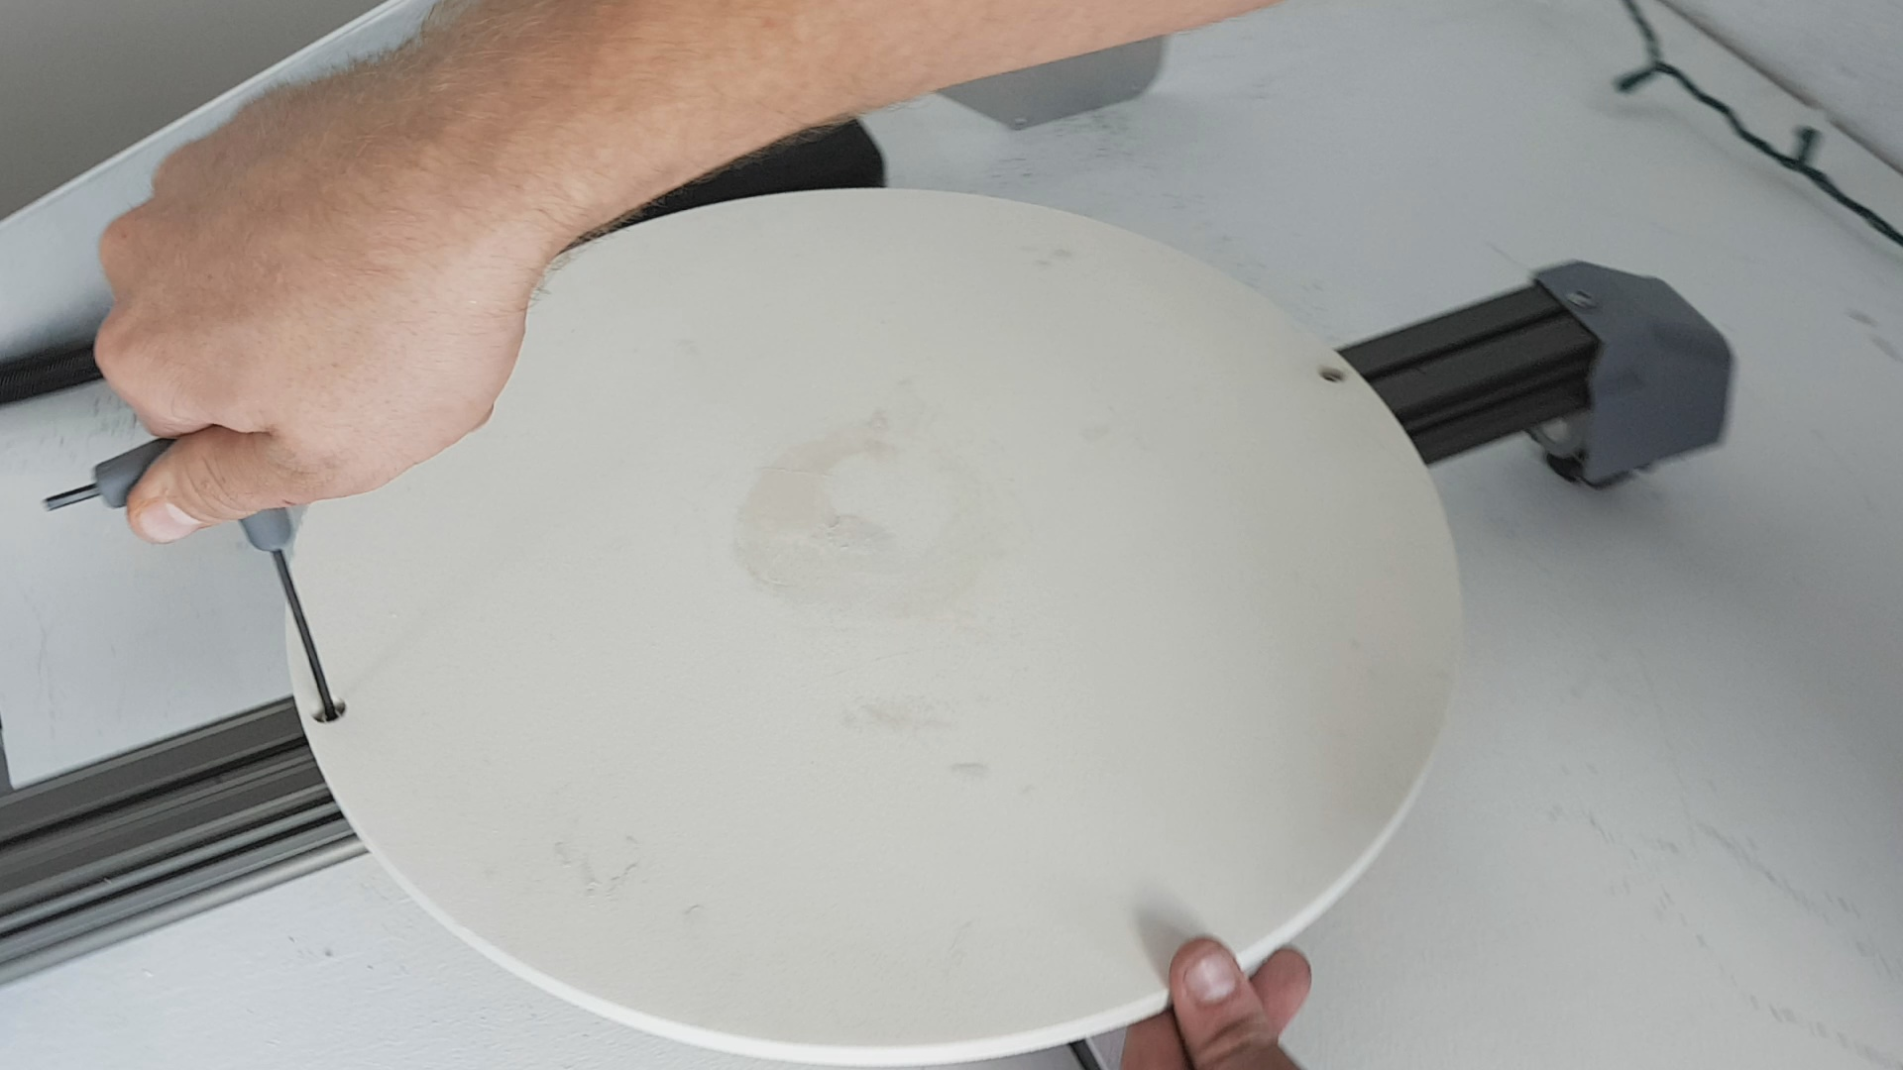

The printer is now fully assembled. When powered on, the printer will be broadcasting its own WiFi network for your printer model. Connect to it, the default password is: 12345678
Once connected, open a web browser and type in: 192.168.42.14
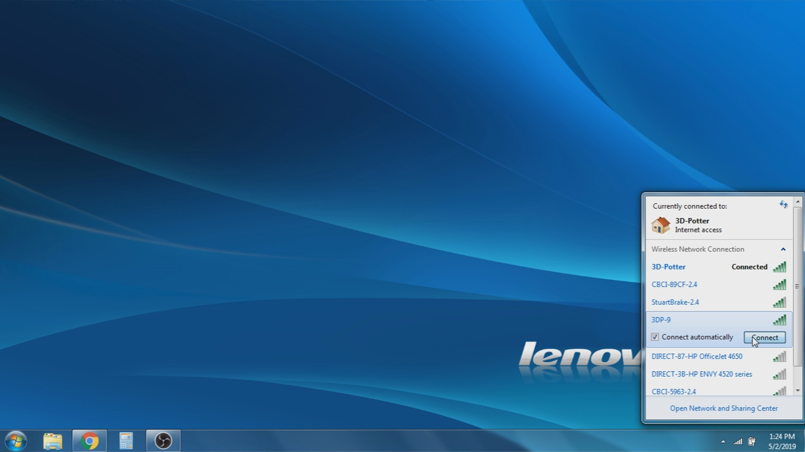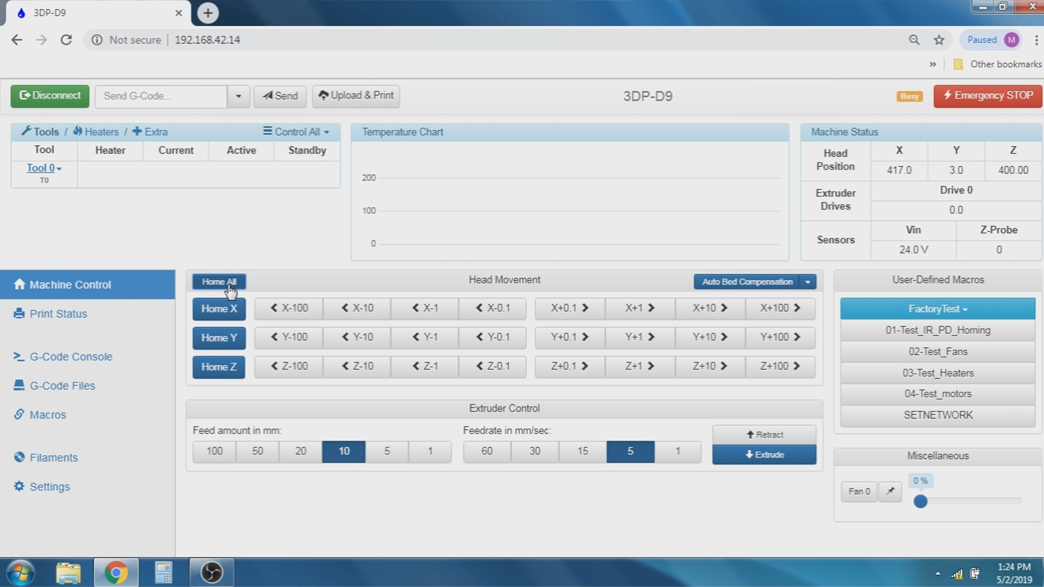

Your printer is now ready for use.

3D Potter, Inc.
403 SE Monterey Road
34994 Stuart, Florida

Hours:
Mon-Fri 8:30AM-4:00PM EST
Saturday 9:00AM-12:00PM EST (Gallery Only)
Sunday Closed

Office/Tech Support: (772) 888-2931
techsupport@3dpotter.com

